Alter do Chão, Pará, Brazil
A small Amazonian village on the Tapajós River where arc-shaped white-sand beaches rise from turquoise-green water — Ilha do Amor earns its nickname 'the Caribbean of the Amazon' every dry season.
⚓ Tender / small-boat transfer · 🕒 Typical call: 6–8 hrs · 💵 Brazilian Real (BRL) · 🗣️ Portuguese
✍️ MY DAY IN PORT (FILL IN)
Ship / Date
In port | arrive ______ · all aboard ______
Booked excursion
Notes / meeting point
GETTING ASHORE
- Docking: Tender to village waterfront
- Walk to center: ~5 min from tender landing
- Best For: River beaches · Amazon nature
- Don't Miss: Ilha do Amor at low water
GETTING AROUND
- 🚕 Taxi: R–160 (~–30 USD) one way — If your ship docks at Santarém (34–40 km away), taxis are available for the ~40-minute drive. Negotiate price before get
TOP THINGS TO DO
- Ilha do Amor — Love Island Beach — The star of the port: a white-sand river beach that emerges from the Tapajós during the dry season (roughly July–December), with…
- Floresta Nacional do Tapajós — A vast protected Amazon rainforest reserve just across the river, with guided jungle walks, towering primary-forest trees…
- Lago Verde & Caiman Spotting — A scenic green lagoon on the edge of the village, ringed by flooded forest in the wet season.
- Borari Indigenous Village & Crafts — The Borari people are the original inhabitants of the area.
- Serra da Piraoca Viewpoint Hike — A short but rewarding hike up the sandstone Serra da Piraoca ridge on the edge of town for panoramic views over the Tapajós…
BEST WALKS
- Village square to Lago Verde: ~1 km · 30 min · easy — A gentle stroll from the tender landing through the village praça, past the craft stalls and the…
- Serra da Piraoca trail: ~2 km · 1 hr · moderate — From the village edge, a footpath climbs the sandstone ridge of the Serra da Piraoca for sweeping…
WEATHER · DAYLIGHT · MONEY
Month | High °F | Low °F | Rainy days
May | 85 | 76 | 29
Jul | 86 | 77 | 19
Sep | 90 | 79 | 7
Daylight: May 6:36AM–6:36PM · Jul 6:46AM–6:45PM · Sep 6:32AM–6:37PM
cruiseports.org/alter-do-chao · Confirm terminal & all-aboard time with your ship

Alter do Chão, Pará, Brazil — Port Map
Red = walkable sights · Amber = excursions farther out · P = cruise terminal
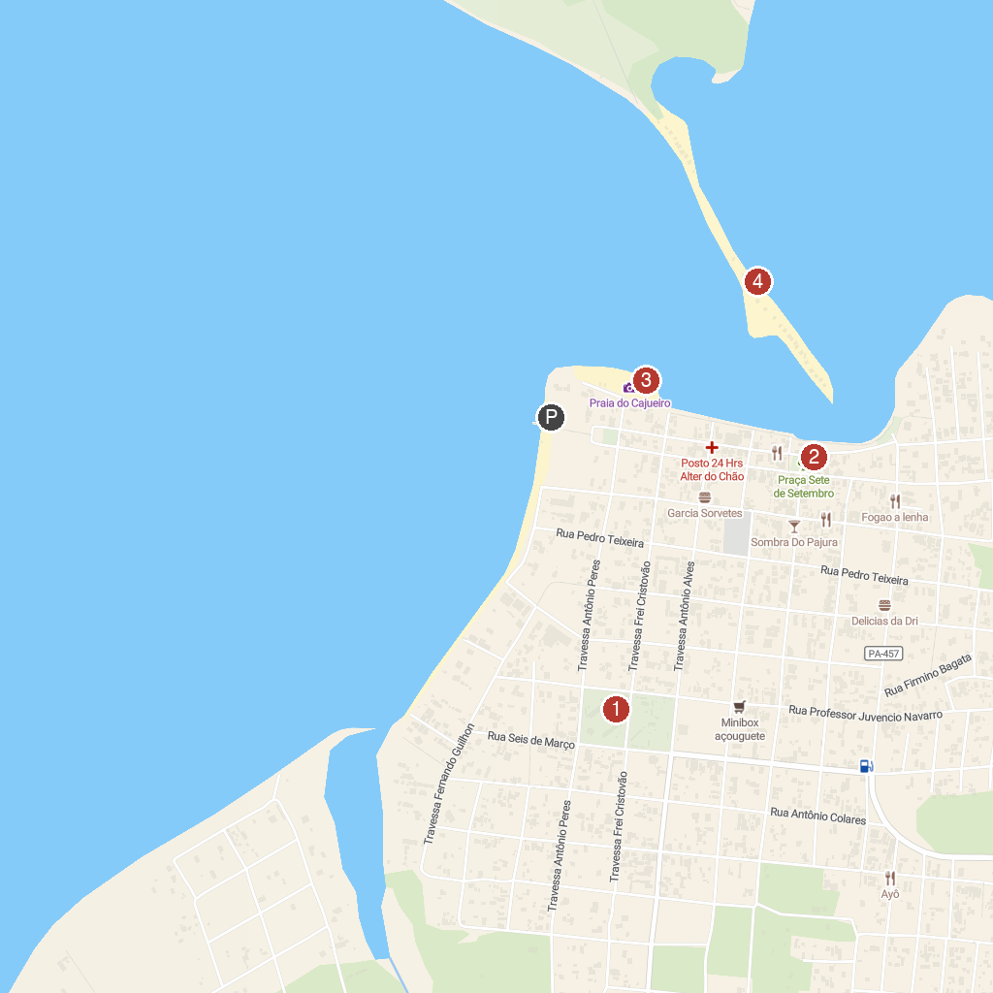
MAP KEY
1. Square Sairé (Sairódromo) | 3. Cajueiro Beach
2. Alter do Chão Brasil | 4. Alter do Chão
P. Cruise port / terminal
Map © MapTiler © OpenStreetMap contributors · cruiseports.org

