Alphonse Islands, Outer Islands, Seychelles
One of the Indian Ocean's most remote and pristine atolls, Alphonse is a conservation haven where giant tortoises roam white-sand flats and world-class fly fishing draws anglers from every continent.
⚓ Tender / Zodiac only · 🕒 Typical call: 4-6 hrs · 💵 USD / Seychellois Rupee · 🗣️ English & French · 🐢 Wildlife-rich atoll
✍️ MY DAY IN PORT (FILL IN)
Ship / Date
In port | arrive ______ · all aboard ______
Booked excursion
Notes / meeting point
GETTING ASHORE
- Docking: Anchor offshore; Zodiac or tender to beach — no pier
- Walk to centre: No town; small resort and conservation area only
- Best For: Snorkelling, fly fishing, giant tortoises, pristine beaches
- Don't Miss: The shallow flats of St. François Atoll at low tide
GETTING AROUND
- 📱 Rideshare: ❌ not available
TOP THINGS TO DO
- Giant Tortoise & Turtle Encounter — Walk the island interior with an Island Conservation Society guide to observe Aldabra giant tortoises roaming freely, and learn…
- Fly Fishing the St. François Flats — Wade or skiff-fish 10,000 acres of hard white-sand flats at St.
- Snorkelling the Alphonse Reef — Snorkel along the outer reef wall and lagoon bommies where manta rays, reef sharks, parrotfish, and colourful damselfish are…
- Scuba Diving — The Alphonse Wall — Dive the dramatic outer wall of Alphonse Atoll, dropping through coral formations with pelagic encounters including sharks, large…
- Kayak & SUP Lagoon Exploration — Paddle the calm turquoise lagoon on a kayak or stand-up paddleboard, drifting over shallow coral gardens and mangrove edges at…
BEST WALKS
- Alphonse Island Perimeter Walk: ~4 km loop | Easy | 45-60 min — A flat sandy circuit of Alphonse Island passing beach bungalows, the resort jetty, coconut palm…
WEATHER · DAYLIGHT · MONEY
Month | High °F | Low °F | Rainy days
May | 82 | 80 | 20
Jul | 78 | 76 | 15
Sep | 79 | 77 | 13
Daylight: May 6:31AM–6:19PM · Jul 6:42AM–6:27PM · Sep 6:22AM–6:25PM
cruiseports.org/alphonse-islands-seychelles · Confirm terminal & all-aboard time with your ship

Alphonse Islands, Outer Islands, Seychelles — Port Map
Red = walkable sights · Amber = excursions farther out · P = cruise terminal
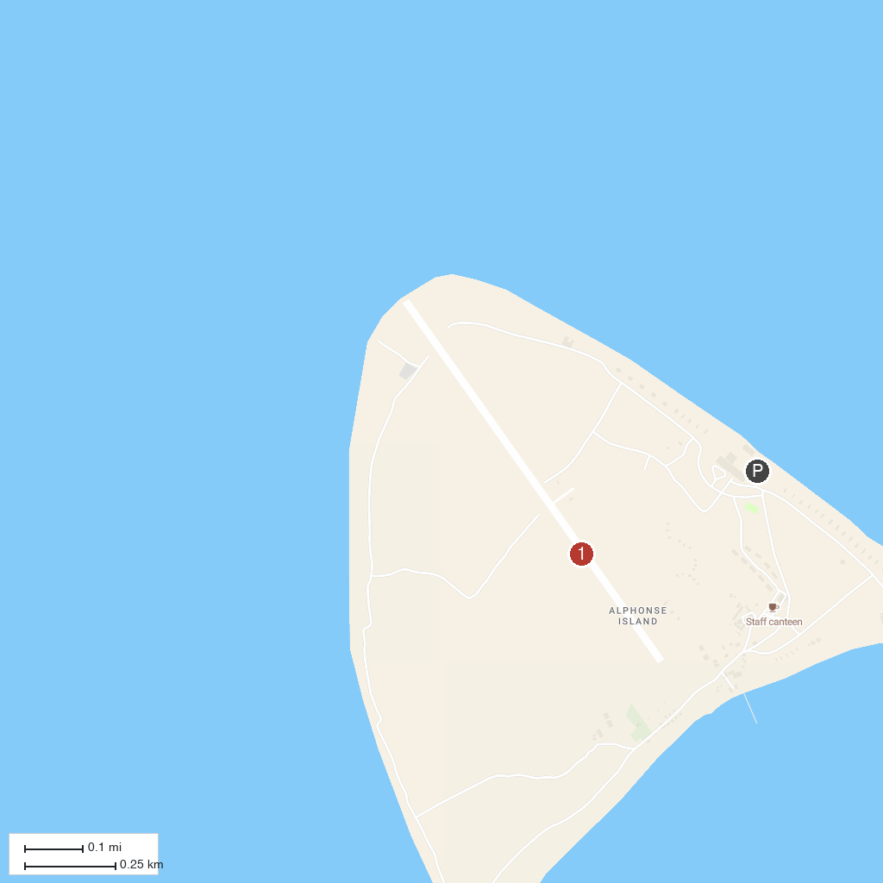
MAP KEY
1. Alphonse Island
P. Cruise port / terminal
Map © MapTiler © OpenStreetMap contributors · cruiseports.org

