Alpena, Michigan, USA
Home to nearly 200 sunken ships in crystal-clear freshwater, Alpena is the Great Lakes' most surprising shore day — part shipwreck museum, part small-town Michigan gem.
⚓ Tender (anchor in Thunder Bay) · 🕒 Typical call: 7-9 hrs · 💵 US Dollar · 🗣️ English
✍️ MY DAY IN PORT (FILL IN)
Ship / Date
In port | arrive ______ · all aboard ______
Booked excursion
Notes / meeting point
GETTING ASHORE
- Docking: Ships anchor in Thunder Bay; shuttle boats to city dock
- Walk to center: ~5 min on foot from shuttle landing to downtown
- Best For: Shipwreck history, glass-bottom boat tours, walking
- Don't Miss: Great Lakes Maritime Heritage Center (free admission)
GETTING AROUND
- 🚕 Taxi: ~– — Local cabs include Tipsy Taxi (989-590-1757), City Cab (989-358-8294), and Jack Cab (989-340-0295). Call ahead as dispat
- 📱 Rideshare: ✅ Uber, Lyft
TOP THINGS TO DO
- Glass-Bottom Boat Shipwreck Tour — Board the Lady Michigan for a narrated 2.5-hour cruise over well-preserved 19th-century wrecks in Thunder Bay.
- Great Lakes Maritime Heritage Center — Free admission to the national marine sanctuary headquarters.
- Presque Isle Lighthouse Tour — Drive or join a guided tour to Old Presque Isle Lighthouse (1840) and the taller New Presque Isle Lighthouse (1870) — both open…
- Fossil Hunting at Rockport State Recreation Area — A former limestone quarry north of town where 400-million-year-old Devonian fossils are exposed in the rock.
- Downtown Alpena Walk & Local Brews — Stroll the compact downtown for murals, galleries, and a surprisingly vibrant food and drink scene — including a local brewery…
BEST WALKS
- Waterfront Bi-Path & Heritage Center Loop: 1.5 miles · Easy · 30-45 min — From the city boat harbor, follow the paved Alpena Bi-Path south along the Thunder Bay River to the…
- Downtown Art & Mural Walk: 0.75 miles · Easy · 20-30 min — A self-guided loop through Alpena's downtown spotting public murals, galleries, and waterfront…
WEATHER · DAYLIGHT · MONEY
Month | High °F | Low °F | Rainy days
May | 58 | 44 | 10
Jul | 75 | 62 | 11
Sep | 68 | 57 | 9
Daylight: May 6:04AM–8:56PM · Jul 6:01AM–9:17PM · Sep 7:13AM–7:43PM
cruiseports.org/alpena-mi · Confirm terminal & all-aboard time with your ship

Alpena, Michigan, USA — Port Map
Red = walkable sights · Amber = excursions farther out · P = cruise terminal
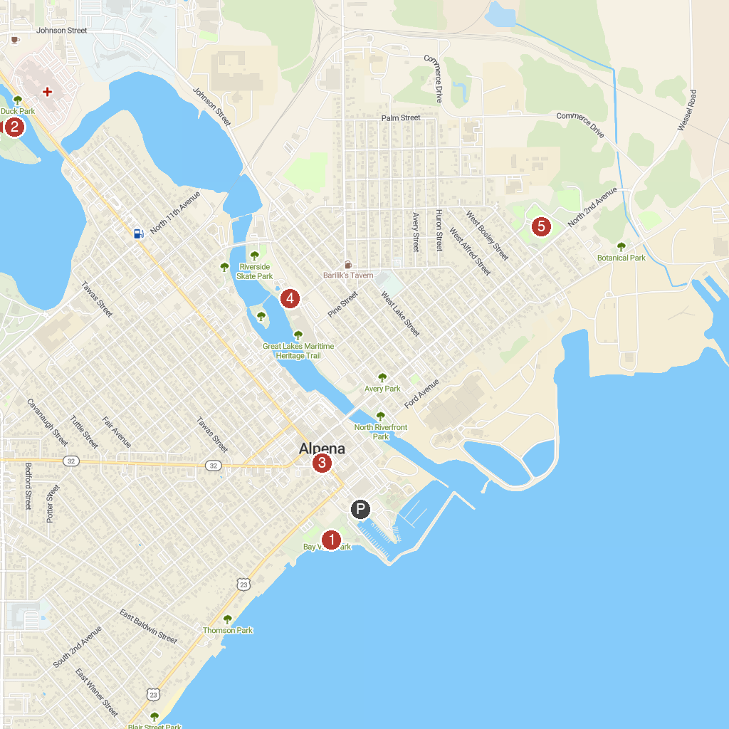
MAP KEY
1. Bay View Park | 5. Great Lakes Maritime Heritage Center
2. Island Park | 6. McRae Park
3. Sunken Lake Park | 7. Long Lake Park
4. Downtown Alpena, Michigan | 8. Beaver Lake County Park
P. Cruise port / terminal
Map © MapTiler © OpenStreetMap contributors · cruiseports.org

