Alotau, Milne Bay Province, Papua New Guinea
Capital of Milne Bay Province and site of the first Allied land victory over Japan in WWII, Alotau greets cruise visitors with vivid sing-sing performances, a bustling market, and some of the friendliest communities in the Pacific.
⚓ Docked (commercial wharf) · 🕒 Typical call: 6-8 hrs · 💵 Papua New Guinean Kina (PGK) · 🗣️ Tok Pisin & English
✍️ MY DAY IN PORT (FILL IN)
Ship / Date
In port | arrive ______ · all aboard ______
Booked excursion
Notes / meeting point
GETTING ASHORE
- Docking: Ships dock at Sanderson Bay wharf — no tendering required
- Walk to center: ~15-20 min walk or short taxi ride to Alotau Market
- Best For: WWII history, traditional sing-sing performances, local markets
- Don't Miss: Alotau War Memorial Park and a dockside sing-sing welcome dance
GETTING AROUND
- 🚕 Taxi: ~PGK 10 / AUD $5 each way to town; negotiate longer trips — Taxis are available around town and at the port on cruise days, but meters are not standard. Agree on the fare before ge
TOP THINGS TO DO
- Traditional Sing-Sing Performance — Watch elaborately costumed village groups perform traditional dances, drumming, and chanting — one of the most striking cultural…
- Alotau War Memorial Park & WWII Sites — The Battle of Milne Bay in 1942 was the first Allied land defeat of Japanese forces in WWII.
- Alotau Market & Town Walk — Dive into daily life at the bustling Alotau Market near the pier — fresh tropical fruit, seafood, carved wooden masks, bilum…
- Snorkeling in Milne Bay — Milne Bay's warm, calm waters shelter over 850 fish species and healthy coral reefs.
- Milne Bay Village Life Visit — Small-group tours to nearby villages offer clay-pot cooking demonstrations, traditional craft making, and a genuine window into…
BEST WALKS
- Wharf to Alotau Market Loop: 1.5 km one-way · 20 min · Easy — Walk from the Sanderson Bay wharf through the commercial strip to the Alotau Town Main Market.
- War Memorial Park Stroll: ~2 km round trip · 30-40 min · Easy — From the town center, walk to the Alotau War Memorial Park with its black granite monument…
WEATHER · DAYLIGHT · MONEY
Month | High °F | Low °F | Rainy days
May | 84 | 75 | 25
Jul | 81 | 74 | 24
Sep | 82 | 74 | 23
Daylight: May 6:05AM–5:43PM · Jul 6:17AM–5:51PM · Sep 5:52AM–5:54PM
cruiseports.org/alotau · Confirm terminal & all-aboard time with your ship

Alotau, Milne Bay Province, Papua New Guinea — Port Map
Red = walkable sights · Amber = excursions farther out · P = cruise terminal
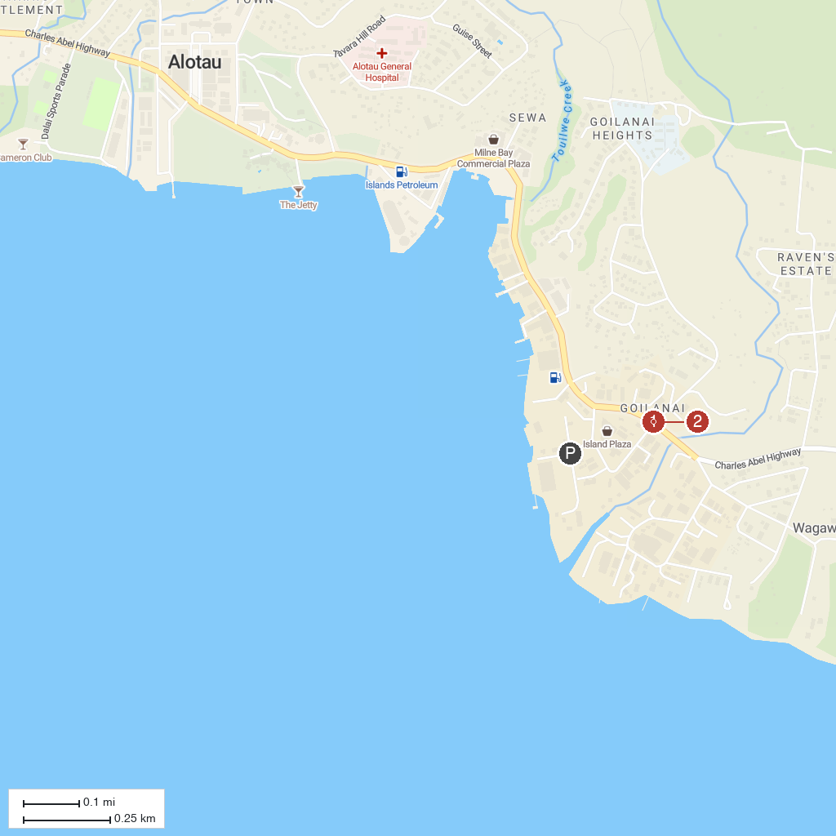
MAP KEY
1. Alotau | 2. Milne Bay War Memorial
P. Cruise port / terminal
Map © MapTiler © OpenStreetMap contributors · cruiseports.org

