Alofi, Niue, South Pacific
A raised coral island the size of a small town, Niue rewards curious cruisers with cathedral chasms, world-class snorkeling, and a quiet so rare it's been called deafening.
⚓ Tender port (no cruise pier) · 🕒 Typical call: 6-8 hrs · 💵 NZD — bring cash, ATM unreliable · 🗣️ English & Niuean spoken · 🐋 Humpback whales Jul–Oct
✍️ MY DAY IN PORT (FILL IN)
Ship / Date
In port | arrive ______ · all aboard ______
Booked excursion
Notes / meeting point
GETTING ASHORE
- Docking: Tender to Alofi Wharf (~10 min)
- Walk to center: 2 min from wharf, short uphill
- Best For: Snorkeling, chasms, nature walks
- Don't Miss: Matapa Chasm & Limu Pools
GETTING AROUND
- 🚕 Taxi: NZD $11–20 (est.) — Very limited taxi availability. Some car-rental companies (Niue Rentals, Alofi Rentals) offer on-demand transfers. Pre-b
- 📱 Rideshare: ❌ not available
TOP THINGS TO DO
- Matapa Chasm & Limu Pools — Visit two of Niue's most iconic spots: Matapa Chasm, a sheer-walled swimming hole once reserved for Niuean royalty, and the…
- Togo Chasm Trek — A guided hike across a jagged makatea (raised coral) forest leads to a hidden oasis at the base of a steep ladder — coconut palms…
- Humpback Whale Watching (Jul–Oct) — Niue is one of the Pacific's premier humpback whale destinations.
- Talava Arches & Coastal Caves — Low-tide access opens up a series of sea arches, caverns, and blowholes along Niue's northwest coast.
- Alofi Village & Niue Museum — Walk Alofi's compact center: the Niue National Museum (Fale Tau Tāoga) covers island history and Polynesian culture; the Alofi…
BEST WALKS
- Alofi Waterfront & Town Center: ⏱ 45 min · 🚶 Easy · flat — From the wharf, climb to the commercial strip and head north along the foreshore path past Tomb…
- Utuko Reef Snorkel Walk: ⏱ 30 min walk · 🤿 bring mask — A short walk south from the wharf leads to Utuko Reef — the easiest reef access from town.
WEATHER · DAYLIGHT · MONEY
Month | High °F | Low °F | Rainy days
May | 79 | 77 | 14
Jul | 76 | 74 | 11
Sep | 77 | 74 | 10
Daylight: May 6:39AM–5:52PM · Jul 6:53AM–5:58PM · Sep 6:15AM–6:14PM
cruiseports.org/alofi · Confirm terminal & all-aboard time with your ship

Alofi, Niue, South Pacific — Port Map
Red = walkable sights · Amber = excursions farther out · P = cruise terminal
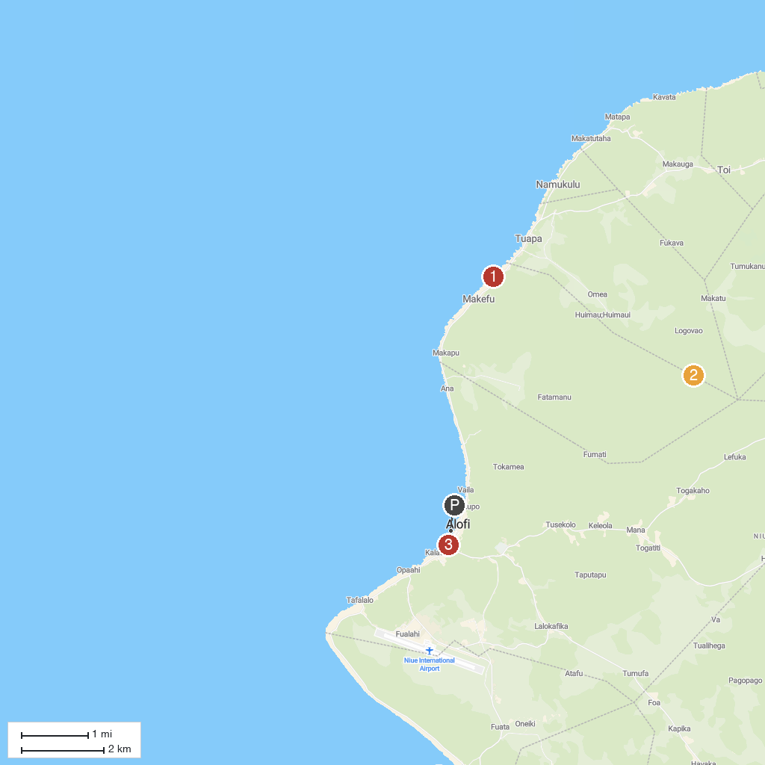
MAP KEY
1. Avaiki Cave | 3. Alofi
2. Matapa Chasm
P. Cruise port / terminal
Map © MapTiler © OpenStreetMap contributors · cruiseports.org

