Almeirim, Pará, Brazil
A quiet bend in the Amazon where expedition ships pause to reveal one of the river's most authentic corners — dense rainforest, scattered riverside communities, and the strange planned-city ghost of Monte Dourado.
⚓ River pier / docked · 🕒 Typical call: 6-8 hrs · 💵 Brazilian Real (BRL) · 🗣️ Portuguese
✍️ MY DAY IN PORT (FILL IN)
Ship / Date
In port | arrive ______ · all aboard ______
Booked excursion
Notes / meeting point
GETTING ASHORE
- Docking: River pier at Terminal Hidroviário de Almeirim (opened 2021); small ships dock directly
- Walk to centre: 5-10 min from the river terminal to Praça do Centenário and the town centre
- Best For: Rainforest wildlife, Amazon river ecology, off-the-beaten-path Amazon towns
- Don't Miss: Monte Dourado — a mid-century planned American-style company town across the Jari River
GETTING AROUND
- 🚕 Taxi: BRL 5–15 — Motorcycle taxis are the most common and affordable way to get around town. Negotiate the fare before riding; cash only.
TOP THINGS TO DO
- Amazon Rainforest Trek — Join a naturalist guide for a trek into the dense forest surrounding Almeirim.
- Amazon River Wildlife Boat Tour — A motorised canoe or small boat excursion along Amazon tributaries and flooded igapó forest — prime territory for pink river…
- Monte Dourado — The Planned City — Hop the passenger ferry across the Jari River to Monte Dourado, a mid-century planned company town built by American…
- Santo Antônio Waterfall (Jari River) — A full-day excursion up the Jari River to the impressive Santo Antônio waterfall — one of the region's standout natural…
- Local Market & Town Walk — Explore Almeirim's town centre on foot — the municipal market, Praça do Relógio, the historic church, and local street food…
BEST WALKS
- Almeirim Town Centre Stroll: 1-2 hrs | Easy | Flat riverside streets — Walk from the river terminal through the town centre to Praça do Centenário, past the Igreja Matriz…
WEATHER · DAYLIGHT · MONEY
Month | High °F | Low °F | Rainy days
May | 85 | 75 | 17
Jul | 90 | 74 | 7
Sep | 92 | 74 | 4
Daylight: May 6:21AM–8:40PM · Jul 6:20AM–8:59PM · Sep 7:16AM–7:42PM
cruiseports.org/almeirim · Confirm terminal & all-aboard time with your ship

Almeirim, Pará, Brazil — Port Map
Red = walkable sights · Amber = excursions farther out · P = cruise terminal
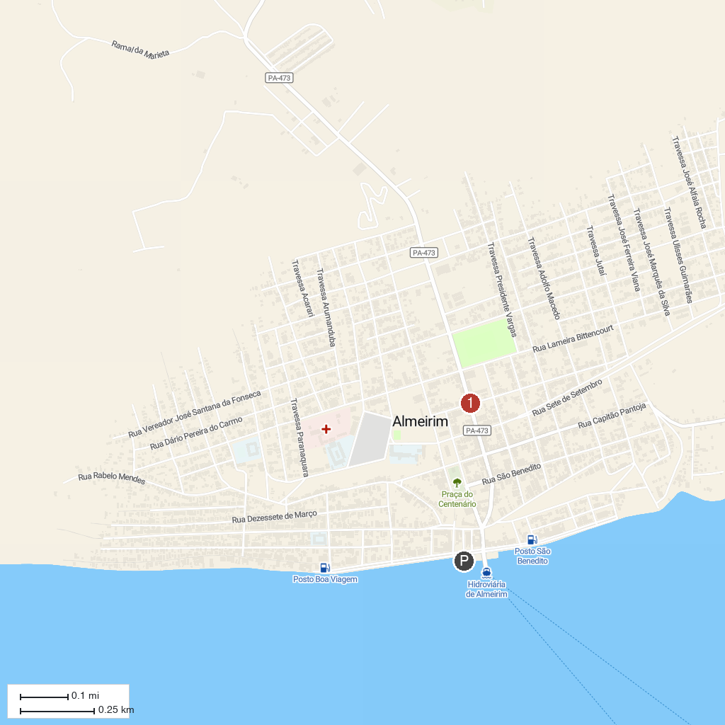
MAP KEY
1. Almeirim
P. Cruise port / terminal
Map © MapTiler © OpenStreetMap contributors · cruiseports.org

