Alkmaar, North Holland, Netherlands
Holland at its most photogenic: a medieval cheese market town of gabled houses, mirror-flat canals, and a world-famous Friday spectacle that's run for 400 years.
⚓ Docked (river quay) · 🕒 Typical call: 6-8 hrs · 💶 Euro (€) · 🗣️ Dutch (English widely spoken)
✍️ MY DAY IN PORT (FILL IN)
Ship / Date
In port | arrive ______ · all aboard ______
Booked excursion
Notes / meeting point
GETTING ASHORE
- Docking: River quay at Kanaalkade or Noorderkade, steps from the old town
- Walk to center: 5-10 min on foot to Waagplein cheese market square
- Best For: Cheese market Fridays (late Mar–Sep), canal walks, Dutch history
- Don't Miss: The Friday morning cheese market at Waagplein (10:00–13:00)
GETTING AROUND
- 🚕 Taxi: €3.10 start + €2.35/km — Local taxis (Taxi Alkmaar / 072) use metered fares. Fixed-price rides can be booked via Staxi app. Credit card accepted,
- 📱 Rideshare: ✅ Uber, Bolt
TOP THINGS TO DO
- Alkmaar Cheese Market — The unmissable Friday tradition.
- Dutch Cheese Museum (Waaggebouw) — Inside the 1582 Weigh House on Waagplein, this interactive museum covers the history of Dutch cheese-making — Gouda, Edam, and…
- Grote Sint Laurenskerk — The largest Gothic church in North Holland above the North Sea Canal, dating to 1470.
- Windmills of the Schermer Polder — About 12 km southeast, the village of Schermerhorn preserves a cluster of original polder windmills in a classic Dutch landscape.
- Canal Boat Tour — See Alkmaar from the water on a guided canal cruise through Verdronkenoord, Luttik Oudorp, and Oudegracht.
BEST WALKS
- Old Town Highlights Loop: 2-3 km · 1-1.5 hrs · Easy — From the quay, walk to Waagplein for the cheese market square, then continue to Grote Sint…
- Hofjes & Hidden Courtyards: 1-2 km · 45-60 min · Easy — Seek out Alkmaar's quiet historic hofjes — almshouse courtyards hidden behind medieval facades.
WEATHER · DAYLIGHT · MONEY
Month | High °F | Low °F | Rainy days
May | 60 | 49 | 10
Jul | 69 | 59 | 12
Sep | 66 | 57 | 11
Daylight: May 5:44AM–9:31PM · Jul 5:36AM–9:56PM · Sep 7:15AM–7:55PM
cruiseports.org/alkmaar · Confirm terminal & all-aboard time with your ship

Alkmaar, North Holland, Netherlands — Port Map
Red = walkable sights · Amber = excursions farther out · P = cruise terminal
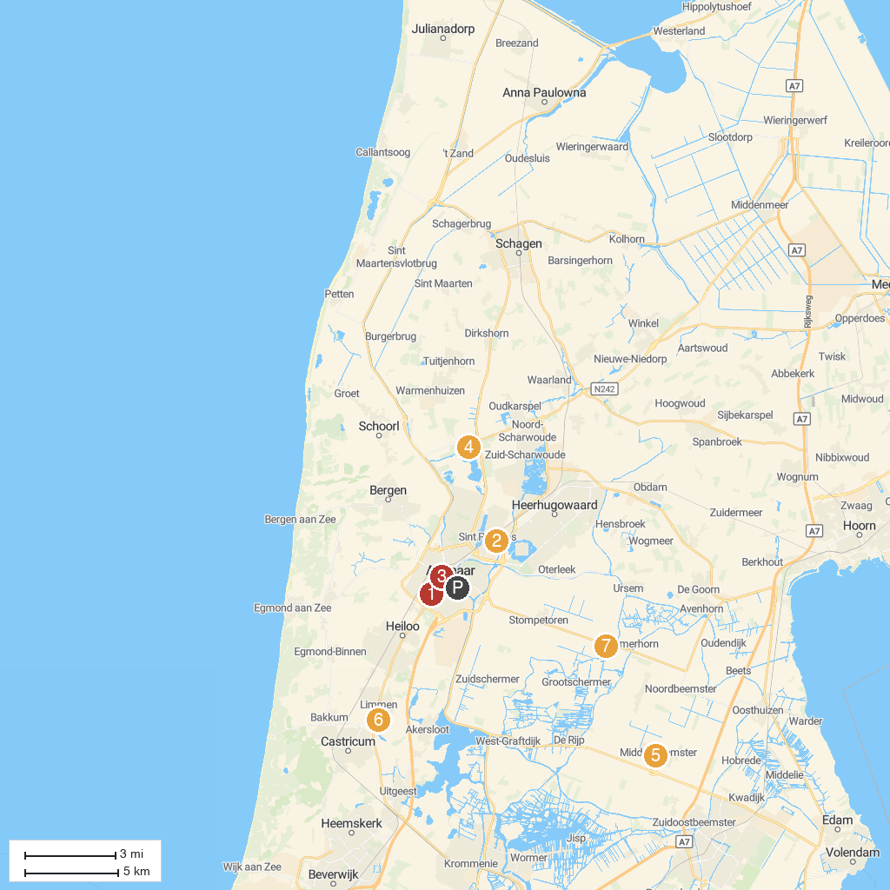
MAP KEY
1. Alkmaarderhout | 5. Speelpark de Swaan
2. Foundation Hortus Alkmaar | 6. Museum Betje Wolff
3. Stedelijk Museum Alkmaar | 7. Hortus Bulborum
4. Vlindorado | 8. De Museummolen
P. Cruise port / terminal
Map © MapTiler © OpenStreetMap contributors · cruiseports.org

