Alken, Rhineland-Palatinate, Germany
One of the Moselle's oldest settlements, Alken rewards walkers with a medieval double-castle above terraced vineyards, a Romanesque church with rare 14th-century frescoes, and the quiet charm of a village little changed in centuries.
⚓ River quay (docked) · 🕒 Typical call: 4–6 hrs · 💶 Currency: Euro (€) · 🗣️ Language: German · 🍷 Moselle Riesling country
✍️ MY DAY IN PORT (FILL IN)
Ship / Date
In port | arrive ______ · all aboard ______
Booked excursion
Notes / meeting point
GETTING ASHORE
- Docking: River quay along Moselstraße; gangway direct to shore
- Walk to center: Steps from the quay into the historic village core
- Best For: Castle hikes, wine tasting, Moselle scenery, medieval history
- Don't Miss: Thurant Castle panorama and Old St. Michael's frescoes
GETTING AROUND
- 🚕 Taxi: €30–€50 to Cochem; €25–€40 to Koblenz — Taxis can be arranged through your cruise line or called from nearby Brodenbach/Hatzenport. Best booked in advance as Al
TOP THINGS TO DO
- Thurant Castle Hike — Burg Thurant is a rare surviving medieval 'double castle', co-owned by the archbishoprics of Cologne and Trier.
- Old St. Michael's Church — First documented in 1015, this Romanesque church holds rare Gothic frescoes from around 1350 in the choir and nave paintings from…
- Moselle Wine Tasting — Alken sits in the heart of the Moselle Riesling belt.
- Day Trip to Cochem — About 25 km up the Moselle, Cochem is a postcard-perfect river town crowned by the spectacularly restored Reichsburg castle.
- Moselle Promenade & Vineyard Walk — A level stroll along the embankment offers classic Moselle scenery — river traffic, terraced Riesling vineyards climbing the…
BEST WALKS
- Village to Thurant Castle Loop: 2.5–3 km | 1.5–2 hrs | Moderate (steep ascent) — From the riverside quay, walk through the village centre past the Fallerport (1256 city gate) and…
- Moselle Promenade Stroll: 1–2 km | 30–45 min | Easy — A flat riverside walk along the Moselstraße embankment in both directions from the ship, with views…
WEATHER · DAYLIGHT · MONEY
Month | High °F | Low °F | Rainy days
May | 65 | 48 | 11
Jul | 74 | 58 | 13
Sep | 68 | 53 | 10
Daylight: May 5:49AM–9:21PM · Jul 5:42AM–9:46PM · Sep 7:14AM–7:52PM
cruiseports.org/alken · Confirm terminal & all-aboard time with your ship

Alken, Rhineland-Palatinate, Germany — Port Map
Red = walkable sights · Amber = excursions farther out · P = cruise terminal
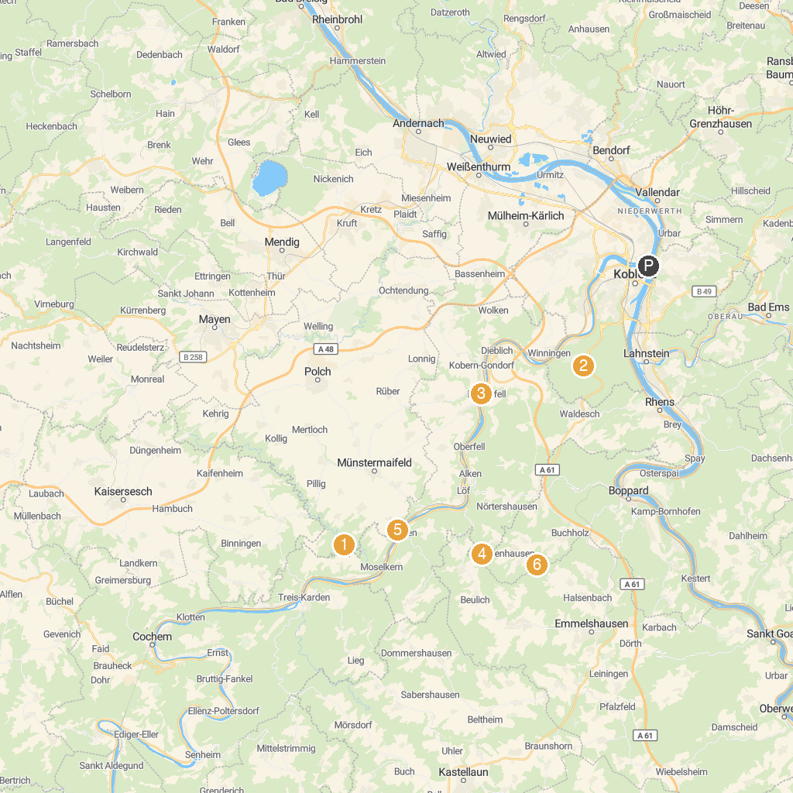
MAP KEY
1. Eltz Castle | 5. Schloss von der Leyen
2. Remstecken | 6. Brandengrabenmühle
3. Stolzenfels Castle | 7. Burg Bischofstein
4. Marksburg | 8. Schloss Schöneck
P. Cruise port / terminal
Map © MapTiler © OpenStreetMap contributors · cruiseports.org

