Aljmaš, Slavonia, Croatia
A tranquil Danube village where river cruise ships tie up steps from a beloved pilgrimage shrine — gateway to Europe's great Pannonian wetlands and the war-memorial city of Vukovar.
⚓ Docked (floating pontoon pier) · 🕒 Typical call: 4-6 hrs · 💵 Euro (EUR) · 🗣️ Croatian · 🦅 Top pick: Kopački Rit birdwatching
✍️ MY DAY IN PORT (FILL IN)
Ship / Date
In port | arrive ______ · all aboard ______
Booked excursion
Notes / meeting point
GETTING ASHORE
- Docking: Floating steel pontoon, right bank of Danube at km 1380+200; up to 2 river vessels
- Walk to center: Pier is in the village — shrine and riverbank are under 5 min on foot
- Best For: Pilgrimage history, Pannonian wetland wildlife, Slavonian food and wine
- Don't Miss: Shrine of Our Lady of Consolation and a boat tour through Kopački Rit
GETTING AROUND
- 🚕 Taxi: €35–45 — Taxis can take you from the port to Osijek city center in about 25 minutes. Pre-arrange with your ship or a local compan
TOP THINGS TO DO
- Shrine of Our Lady of Consolation — The iconic swan-shaped pilgrimage church rebuilt after the Croatian War of Independence is Aljmaš's spiritual heart.
- Kopački Rit Nature Park Boat Tour — One of Europe's largest and best-preserved floodplain wetlands sits just 25 km from the pier.
- Vukovar Memorial City — Thirty-five kilometers downriver, Vukovar carries the visible scars and resilient spirit of the 1991 siege.
- Osijek Baroque Fortress (Tvrđa) — Slavonia's largest city, Osijek, is about 25 km west.
- Slavonian Fish Lunch & Erdut Wine — Aljmaš is known for family-run riverside restaurants serving freshwater fish — catfish, carp, and pike-perch — grilled or stewed…
BEST WALKS
- Village & Shrine Loop: 0.5 km · 15 min · Easy — From the pier walk directly to the Shrine of Our Lady of Consolation, circle the church grounds…
- Aljmaš to Erdut Riverside Path: 10 km one-way · ~3 hrs · Easy — A flat, shaded path follows the Danube bank east through riverside vegetation to the village of…
WEATHER · DAYLIGHT · MONEY
Month | High °F | Low °F | Rainy days
May | 71 | 54 | 12
Jul | 84 | 65 | 7
Sep | 75 | 58 | 8
Daylight: May 5:13AM–8:08PM · Jul 5:10AM–8:29PM · Sep 6:22AM–6:54PM
cruiseports.org/aljmas · Confirm terminal & all-aboard time with your ship

Aljmaš, Slavonia, Croatia — Port Map
Red = walkable sights · Amber = excursions farther out · P = cruise terminal
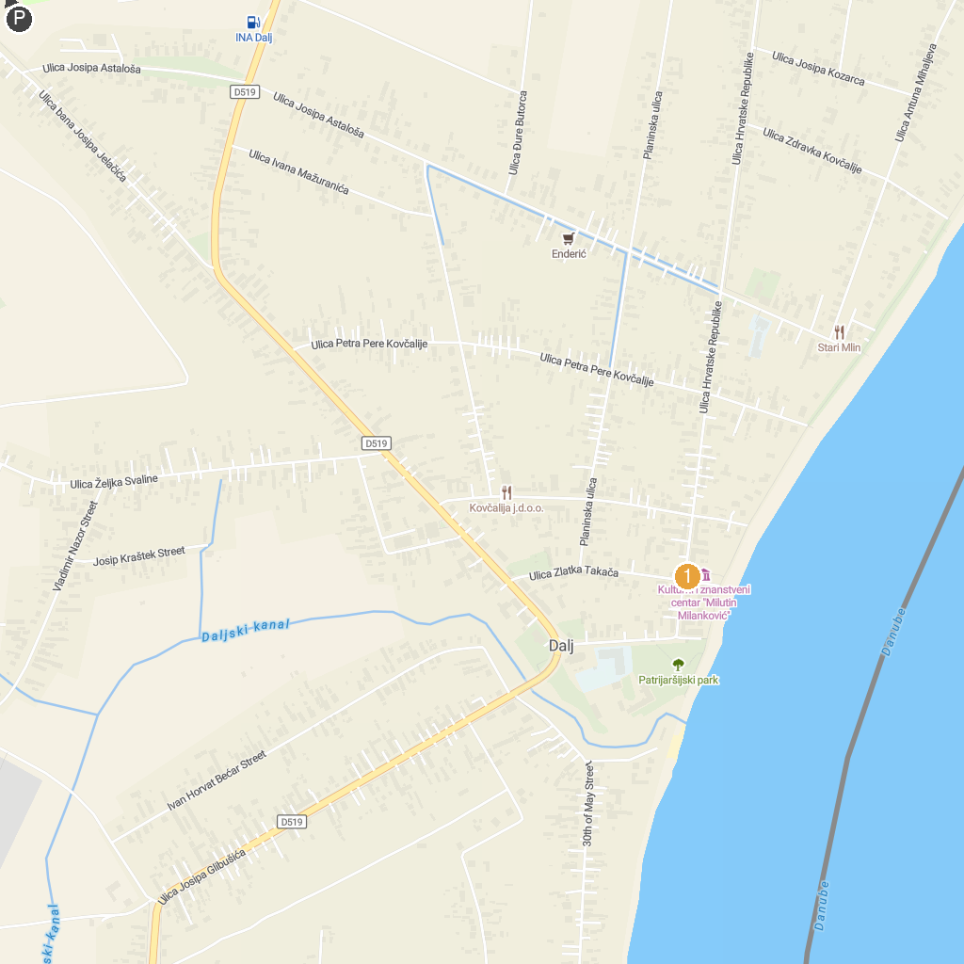
MAP KEY
1. Cultural and Scientific Center "Milutin Milanković" | 2. Pristanište parka prirode Kopački rit
P. Cruise port / terminal
Map © MapTiler © OpenStreetMap contributors · cruiseports.org

