Algoma, Wisconsin, USA
A quiet fishing town on Lake Michigan's western shore, Algoma punches above its size — red lighthouse, underground wine cellars, and some of the Great Lakes' best salmon charters all within walking distance of the pier.
⚓ Tender (anchor offshore) · 🕒 Typical call: 6–8 hrs · 💵 US Dollar (USD) · 🗣️ English
✍️ MY DAY IN PORT (FILL IN)
Ship / Date
In port | arrive ______ · all aboard ______
Booked excursion
Notes / meeting point
GETTING ASHORE
- Docking: Cruise ships anchor offshore on Lake Michigan and tender to the Algoma Marina at the Ahnapee River mouth; no cruise dock
- Walk to Center: The marina is in the heart of town — downtown shops, the lighthouse pier, and Crescent Beach are all within a few minutes' walk
- Best For: Lake Michigan salmon charters, lighthouses, local wine & craft beer
- Don't Miss: Von Stiehl Winery's underground Civil War-era cellars on Navarino Street
GETTING AROUND
- 🚕 Taxi: Call for quote — Door County Cab (+1 920-818-7433) serves the northeastern Wisconsin region. Call ahead as on-demand availability is limi
- 📱 Rideshare: ✅ Uber
TOP THINGS TO DO
- Lake Michigan Salmon Charter — Algoma is one of the top charter-fishing ports on Lake Michigan, famous for Coho and King (Chinook) salmon plus rainbow/steelhead…
- Algoma Pierhead Lighthouse Walk — Stroll the pier at the Ahnapee River mouth to reach the distinctive red steel pierhead lighthouse.
- Von Stiehl Winery Tasting & Cellar Tour — Wisconsin's oldest licensed winery (est.
- Crescent Beach & Boardwalk — A half-mile accessible boardwalk runs along a sandy Lake Michigan beach within easy walking distance of the pier.
- Door County Day Trip — Sturgeon Bay, the gateway to Door County, is about 30 minutes (17 miles) by road.
BEST WALKS
- Waterfront Lighthouse Loop: 1.5 mi · Easy · 30–45 min — From the Ahnapee River landing, walk north along the south pier to the red Algoma Pierhead…
- Downtown & Crescent Beach: 2 mi · Easy · 45–60 min — Head up into the compact downtown grid of shops and galleries, then continue to Crescent Beach and…
WEATHER · DAYLIGHT · MONEY
Month | High °F | Low °F | Rainy days
May | 66 | 49 | 11
Jul | 81 | 65 | 10
Sep | 72 | 58 | 11
Daylight: May 5:27AM–8:13PM · Jul 5:25AM–8:34PM · Sep 6:33AM–7:03PM
cruiseports.org/algoma-wi · Confirm terminal & all-aboard time with your ship

Algoma, Wisconsin, USA — Port Map
Red = walkable sights · Amber = excursions farther out · P = cruise terminal
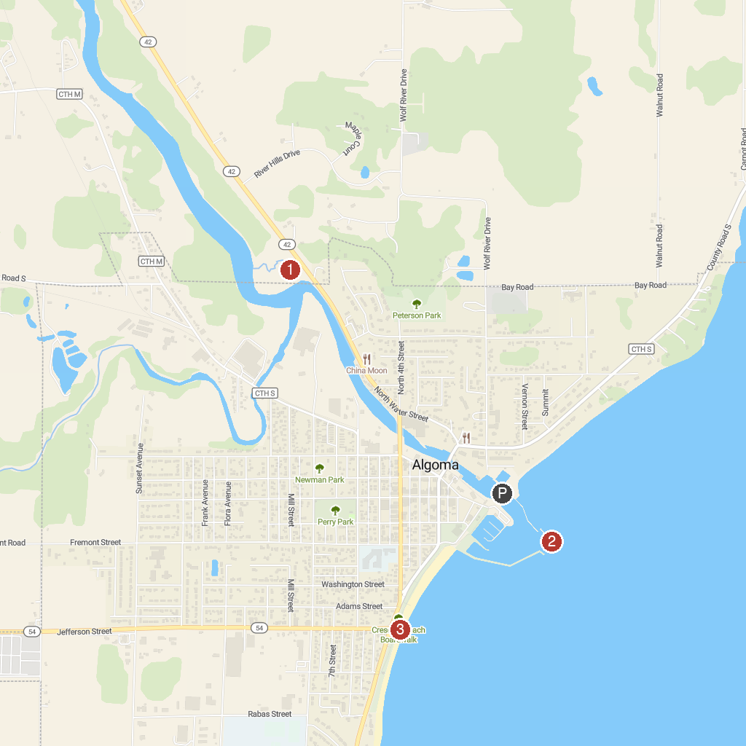
MAP KEY
1. Olson Park | 3. Crescent Beach Boardwalk
2. Algoma Pierhead Lighthouse
P. Cruise port / terminal
Map © MapTiler © OpenStreetMap contributors · cruiseports.org

