Algiers, Algiers Province, Algeria
"Algiers the White" tumbles down steep hillsides to the Mediterranean — a layered city of Ottoman alleyways, French boulevards, and one of Africa's most dramatic waterfronts.
⚓ Docked (no tender) · 🕒 Typical call: 8–10 hrs · 💵 Algerian Dinar (DZD) — cash preferred · 🗣️ Arabic & French · 🛂 Visa often arranged via cruise line
✍️ MY DAY IN PORT (FILL IN)
Ship / Date
In port | arrive ______ · all aboard ______
Booked excursion
Notes / meeting point
GETTING ASHORE
- Docking: Ships dock at Port d'Alger (Gare Maritime) — central, no tender
- Walk to centre: ~15 min on foot to Grande Poste / Casbah entrance
- Best For: History lovers, architecture fans, adventurous independent travellers
- Don't Miss: The Casbah UNESCO labyrinth and a taxi ride to Notre Dame d'Afrique
GETTING AROUND
- 🚕 Taxi: 200–500 DZD (~$1.50–4 USD) — Yellow taxis are plentiful but meters are rarely used — negotiate the fare before you get in. Short rides into the city
TOP THINGS TO DO
- Casbah of Algiers UNESCO Walking Tour — Wind through centuries-old alleyways past Ottoman palaces, traditional courtyard homes, and ancient mosques in this UNESCO World…
- Notre Dame d'Afrique & Bay Views — A short taxi ride climbs to this 19th-century basilica perched on a cliff above the Bay of Algiers.
- Tipasa Roman Ruins Day Trip — Drive 70 km west to Tipasa, a UNESCO World Heritage site where Roman temples, a basilica, and a theatre tumble dramatically into…
- French Quarter & Grande Poste Stroll — Walk the broad Haussmann-style boulevards around Rue Didouche Mourad, admire the Neo-Moorish Grande Poste building, and browse…
- Jardin d'Essai du Hamma — One of the oldest botanical gardens in Africa, established in 1832, with enormous century-old trees, rare plant collections, and…
BEST WALKS
- French Quarter Loop: 2 km · 45 min · Easy — Start at the port gate and head up to the Grande Poste building for photos of its striking…
- Casbah Entrance & Lower Quarter: 1.5 km · 1–2 hrs · Moderate (steep, uneven) — From the port walk north to the lower Casbah entrance near Place des Martyrs.
WEATHER · DAYLIGHT · MONEY
Month | High °F | Low °F | Rainy days
May | 74 | 58 | 6
Jul | 88 | 70 | 0
Sep | 84 | 68 | 4
Daylight: May 5:40AM–7:48PM · Jul 5:40AM–8:06PM · Sep 6:30AM–6:54PM
cruiseports.org/algiers · Confirm terminal & all-aboard time with your ship

Algiers, Algiers Province, Algeria — Port Map
Red = walkable sights · Amber = excursions farther out · P = cruise terminal
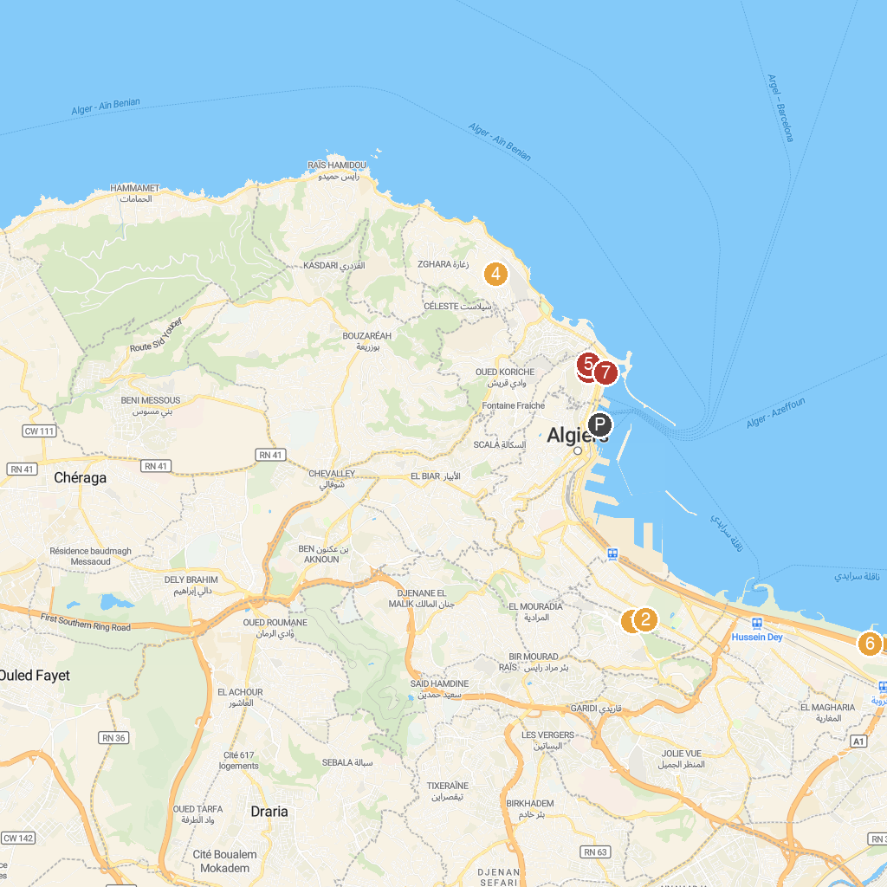
MAP KEY
1. Martyrs Memorial | 5. National Museum of Arts and Popular Traditions
2. National Museum of Fine Arts of Algiers | 6. Sablette
3. Dar Mustapha Pacha | 7. Djamaa el Kebir
4. Church of Notre Dame d'Afrique
P. Cruise port / terminal
Map © MapTiler © OpenStreetMap contributors · cruiseports.org

