Algeciras, Andalusia, Spain
Straddling the narrowest point between Europe and Africa, Algeciras punches well above its size — a working port city that hands cruisers a remarkable menu: the Rock of Gibraltar, a fast ferry to Tangier, kite-surf mecca Tarifa, or simply the old quarter's sherry bars and Moorish walls.
⚓ Docked (North dock or Isla Verde quay) · 🕒 Typical call: 8-10 hrs · 💶 Euro (EUR) · 🗣️ Spanish
✍️ MY DAY IN PORT (FILL IN)
Ship / Date
In port | arrive ______ · all aboard ______
Booked excursion
Notes / meeting point
GETTING ASHORE
- Docking: All ships dock — no tendering. Large ships use the 1,000 m North dock (free shuttle to centre); smaller vessels berth at Isla Verde Interior Quay (~10-min walk to town).
- Walk to centre: 10-15 min on foot from the North dock via free port shuttle; Isla Verde quay is walkable in ~10 min.
- Best For: Gibraltar day trips, Morocco ferry, Tarifa wind sports, dolphin & whale watching
- Don't Miss: The Rock of Gibraltar's Barbary macaques and St. Michael's Cave; or a fast ferry to Tangier
GETTING AROUND
- 🚕 Taxi: €5–€7 — Taxis are readily available outside the terminal for the short 3 km ride into Algeciras city center. Meter-based fares;
- 📱 Rideshare: ✅ Uber
TOP THINGS TO DO
- Rock of Gibraltar — Catch a bus to La Línea de la Concepción (45 min, ~€3) then walk across the border into Gibraltar.
- Tangier Day Trip by Ferry — FRS and Baleària run ferries from Algeciras to Tangier MED port (ferry port, ~35 min) or from nearby Tarifa to Tangier Ville…
- Tarifa: Wind, Whales & the Southern Tip — Tarifa (22 km south, 45 min by hourly bus, ~€2-5) is Europe's southernmost point and the world capital of windsurfing and…
- Bay of Gibraltar Dolphin & Whale Watching — The Strait of Gibraltar is one of Europe's richest cetacean corridors.
- Algeciras Old Quarter Walking Tour — Algeciras's compact historic core is walkable from the port.
BEST WALKS
- Historic Algeciras: Port to Plaza Alta: 1.5 km · 20 min · Easy — A short stroll through the city core, taking in the Merinide Walls archaeological park, Parque…
- Gibraltar Frontier Walk (La Línea): ~1 km at border · Easy — After the bus drops you at La Línea de la Concepción bus station, walk south through town to the…
WEATHER · DAYLIGHT · MONEY
Month | High °F | Low °F | Rainy days
May | 70 | 60 | 4
Jul | 80 | 68 | 0
Sep | 77 | 67 | 6
Daylight: May 7:15AM–9:20PM · Jul 7:16AM–9:38PM · Sep 8:04AM–8:28PM
cruiseports.org/algeciras · Confirm terminal & all-aboard time with your ship

Algeciras, Andalusia, Spain — Port Map
Red = walkable sights · Amber = excursions farther out · P = cruise terminal
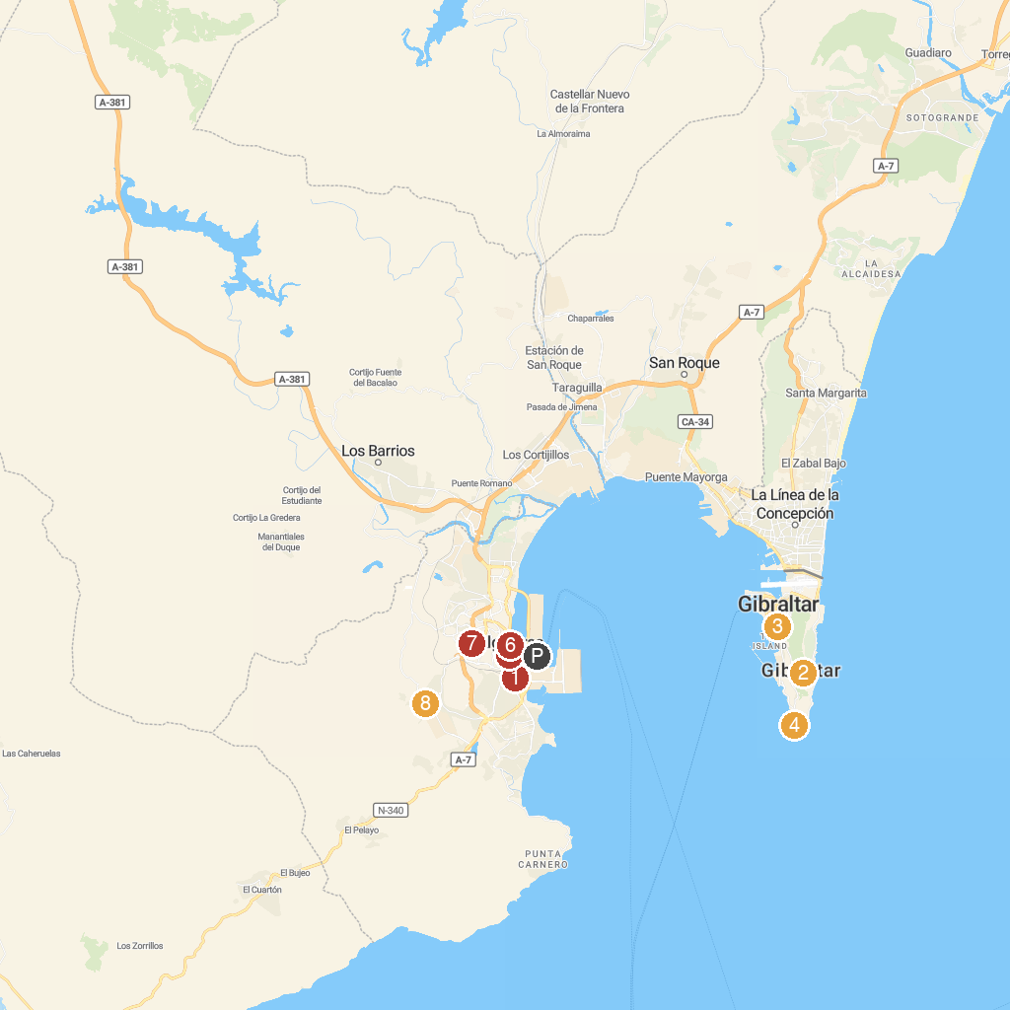
MAP KEY
1. Parque de Las Acacias | 5. Parroquia of Our Lady of La Palma
2. Saint Michael's Cave | 6. Murallas Meriníes
3. The Gibraltar National Museum | 7. Bahia Park
4. Shrine of our Lady of Europe | 8. Sendero Rio De La Miel
P. Cruise port / terminal
Map © MapTiler © OpenStreetMap contributors · cruiseports.org

