Dutch Harbor (Unalaska), Aleutian Islands, USA
The edge of America — Dutch Harbor is a rugged, windswept fishing port where WWII bunkers crown volcanic hills, bald eagles outnumber tourists, and the crab boats from Deadliest Catch tie up at the dock.
⚓ Docked (commercial fishing pier) · 🕒 Typical call: 6-8 hrs · 💵 USD · 🗣️ English · 🌧️ Weather: cool, windy, wet year-round
✍️ MY DAY IN PORT (FILL IN)
Ship / Date
In port | arrive ______ · all aboard ______
Booked excursion
Notes / meeting point
GETTING ASHORE
- Docking: Commercial fishing piers (UniSea or Kloosterboer dock); shuttle buses usually run to town
- Walk to center: 2–3 miles from pier — shuttle or taxi needed
- Best For: WWII history, wildlife, fishing culture, off-the-beaten-path adventure
- Don't Miss: Fort Schwatka bunkers on Mt. Ballyhoo and the Church of the Holy Ascension
GETTING AROUND
- 🚕 Taxi: $5–$10 to town — Several local taxi operators serve the port (Island Taxi, Star Taxi, Aleutian Taxi, others). Taxis are typically large v
- 📱 Rideshare: ❌ not available
- 🚌 Hop-on hop-off: ✅
TOP THINGS TO DO
- Fort Schwatka & WWII Bunkers on Mt. Ballyhoo — Dutch Harbor was bombed by Japan in June 1942, and the nearby Aleutian islands of Attu and Kiska became the only U.S.
- Museum of the Aleutians — This small but excellent museum covers 9,000 years of Unangan (Aleut) culture alongside WWII artifacts.
- Wildlife & Seabird Boat Tour — The waters around Unalaska Island teem with bald eagles, puffins, auklets, sea lions, harbor seals, and sea otters.
- Deadliest Catch Dock Walk — The Bering Sea crab fleet — yes, the boats from the TV show — ties up right here.
- Church of the Holy Ascension — A beautifully preserved Russian Orthodox cathedral; the current building was completed in 1896 on a site that has had churches…
BEST WALKS
- Downtown Unalaska Heritage Walk: 1-2 hrs · Easy · Culture & History — From the town center, walk to the Church of the Holy Ascension, stroll past the Museum of the…
- Bunker Hill Loop: 2-3 hrs · Moderate · WWII & Views — A short but steep hike above town leads to WWII-era gun emplacements and panoramic views over Dutch…
WEATHER · DAYLIGHT · MONEY
Month | High °F | Low °F | Rainy days
May | 45 | 38 | 18
Jul | 55 | 49 | 14
Sep | 53 | 46 | 16
Daylight: May 7:03AM–11:02PM · Jul 6:55AM–11:28PM · Sep 8:40AM–9:20PM
cruiseports.org/aleutian-islands · Confirm terminal & all-aboard time with your ship

Dutch Harbor (Unalaska), Aleutian Islands, USA — Port Map
Red = walkable sights · Amber = excursions farther out · P = cruise terminal
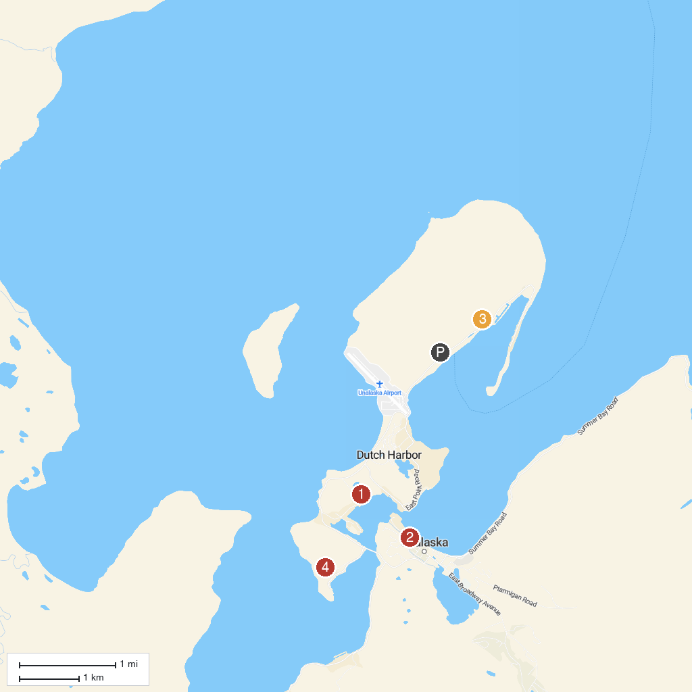
MAP KEY
1. Museum of the Aleutians | 3. Mount Ballyhoo, Unalaska
2. Church of the Holy Ascension, Unalaska | 4. Bunker Hill, Dutch Harbor
P. Cruise port / terminal
Map © MapTiler © OpenStreetMap contributors · cruiseports.org

