Alderney, Channel Islands, UK
Britain's most remote Channel Island delivers a rare combination: wartime history, world-class seabird colonies, and golden beaches — all walkable from the tender dock at Braye Harbour.
⚓ Tender port (no cruise berth) · 🕒 Typical call: 6-8 hrs · 💷 Currency: Pound sterling (GBP) · 🗣️ Language: English
✍️ MY DAY IN PORT (FILL IN)
Ship / Date
In port | arrive ______ · all aboard ______
Booked excursion
Notes / meeting point
GETTING ASHORE
- Docking: Tender only — ships anchor in Braye Bay; passengers land at the passenger pontoon in Braye Harbour
- Walk to centre: 10-15 min uphill walk (or short taxi ride) from Braye Harbour to St Anne town
- Best For: WWII history, seabird watching (puffins, gannets), coastal walking, unspoiled beaches
- Don't Miss: Les Étacs gannet colony boat tour, Alderney Railway, St Anne's Church & Museum
GETTING AROUND
- 🚕 Taxi: ~£8-£15 short ride; tours higher — Local taxi firms serve the island and are the easiest backup for the climb from Braye Harbour to St Anne or for reaching
TOP THINGS TO DO
- Seabird Colony Boat Tour — The Alderney Wildlife Trust runs round-island boat trips past Les Étacs (home to one of Europe's largest northern gannet…
- WWII Occupation Sites — Alderney was the only British territory with Nazi forced-labour camps (Lager Sylt, Lager Norderney).
- Coastal Path Walk — The 10-mile perimeter coastal path circles the entire island, passing Victorian forts, clifftop views toward France, secluded…
- Alderney Railway Ride — Ride the Channel Islands' only railway in restored London Underground carriages from Braye Road station to Mannez Quarry.
- St Anne Town & Museum — Alderney's only town has cobbled streets, Georgian houses, independent shops, and several pubs.
BEST WALKS
- Braye Harbour to St Anne: 1 mile | Easy | 15-20 min — Walk up Braye Road from the harbour pontoon into the heart of St Anne.
- Braye Beach to Fort Albert & Saye Beach: 2 miles | Easy-Moderate | 1-1.5 hrs one way — From Braye beach, follow the coastal path east past Fort Albert (Victorian gun battery) around to…
WEATHER · DAYLIGHT · MONEY
Month | High °F | Low °F | Rainy days
May | 54 | 51 | 9
Jul | 62 | 59 | 7
Sep | 63 | 60 | 10
Daylight: May 5:24AM–8:47PM · Jul 5:18AM–9:10PM · Sep 6:45AM–7:21PM
cruiseports.org/alderney-island · Confirm terminal & all-aboard time with your ship

Alderney, Channel Islands, UK — Port Map
Red = walkable sights · Amber = excursions farther out · P = cruise terminal
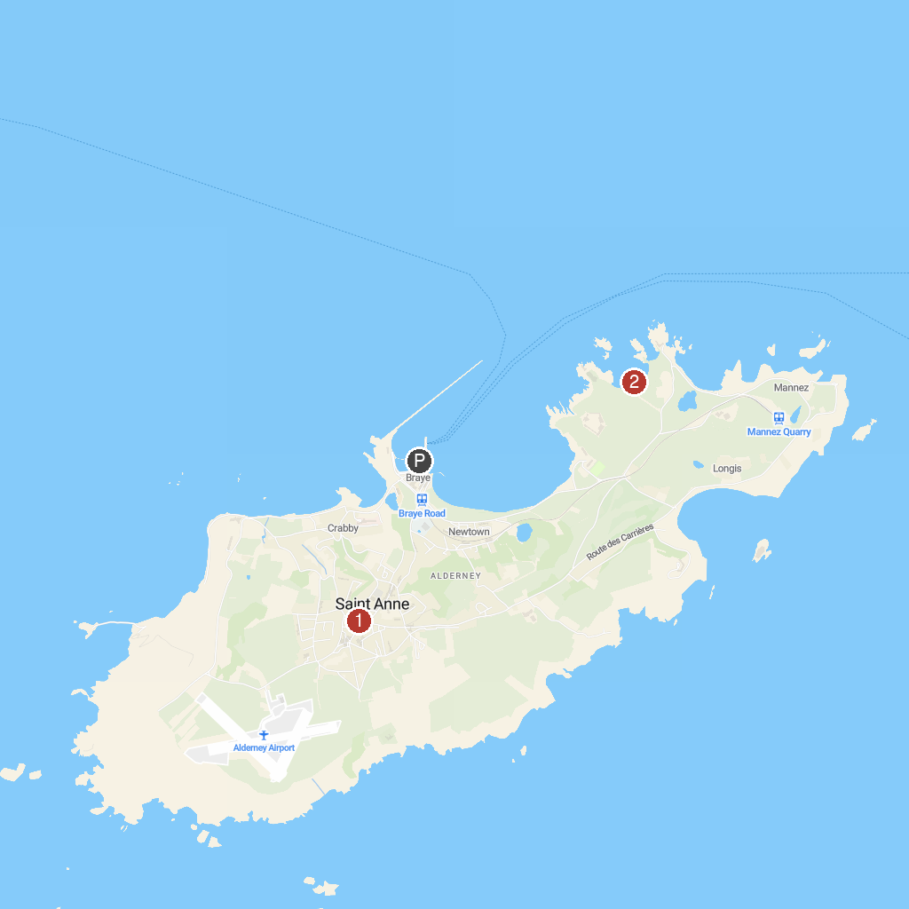
MAP KEY
1. Alderney Museum | 2. Saye Beach
P. Cruise port / terminal
Map © MapTiler © OpenStreetMap contributors · cruiseports.org

