Aldabra Atoll, Outer Islands, Seychelles
One of the most remote and protected ecosystems on Earth, Aldabra Atoll rewards the few expedition cruisers who make it here with 100,000+ free-roaming giant tortoises, a flightless rail found nowhere else, and reefs that have barely seen a human shadow.
⚓ Zodiac tender (no pier or jetty) · 🕒 Typical call: 4–6 hrs · 💵 Currency: Seychellois Rupee (SCR) — no shops on-island · 🗣️ Language: English / French · 🌿 UNESCO World Heritage Site
✍️ MY DAY IN PORT (FILL IN)
Ship / Date
In port | arrive ______ · all aboard ______
Booked excursion
Notes / meeting point
GETTING ASHORE
- Docking: Zodiac tender to shore — expedition vessels anchor offshore; no pier or jetty exists
- Walk to Center: Research station on Picard (West) Island is the only inhabited point; access via SIF guides only
- Best For: Wildlife encounters: giant tortoises, flightless Aldabra Rail, frigatebirds, green turtles, reef sharks
- Don't Miss: Walking among free-roaming Aldabra Giant Tortoises — 100,000+ live here, the world's largest wild population
GETTING AROUND
TOP THINGS TO DO
- Giant Tortoise Encounter on Picard Island — Walk the limestone scrub of Picard Island alongside free-roaming Aldabra Giant Tortoises — over 100,000 live on the atoll.
- Aldabra Rail & Endemic Birdwatching — Search for the Aldabra Rail — the Indian Ocean's last flightless bird — along with the Aldabra Drongo, frigatebird colonies (the…
- Zodiac Lagoon Cruise & Snorkelling — Explore the vast tidal lagoon and channel passages by inflatable boat.
- Turtle Nesting & Nesting Beach Walk — Seasonally (primarily November–February), green sea turtles nest on Aldabra's beaches in numbers rare across the Indian Ocean.
- Champignon Limestone Trail — Pick your way across Aldabra's extraordinary eroded limestone 'champignon' formations — a moonscape riddled with tide pools, land…
BEST WALKS
- Picard Island Tortoise Trail: 1.5–3 km | 1–2 hrs | Guided only | Rough limestone terrain — The main guided walk from the SIF research station into the scrub interior of Picard Island…
- Lagoon Channel Shore Walk: 1–2 km | 45–90 min | Guided | Flat sand/coral — A gentler shoreline walk along the lagoon-side of Picard Island, passing mangrove edges and shallow…
WEATHER · DAYLIGHT · MONEY
Month | High °F | Low °F | Rainy days
May | 83 | 80 | 22
Jul | 79 | 77 | 15
Sep | 80 | 78 | 18
Daylight: May 7:00AM–6:41PM · Jul 7:12AM–6:49PM · Sep 6:48AM–6:51PM
cruiseports.org/aldabra-atoll-seychelles · Confirm terminal & all-aboard time with your ship

Aldabra Atoll, Outer Islands, Seychelles — Port Map
Red = walkable sights · Amber = excursions farther out · P = cruise terminal
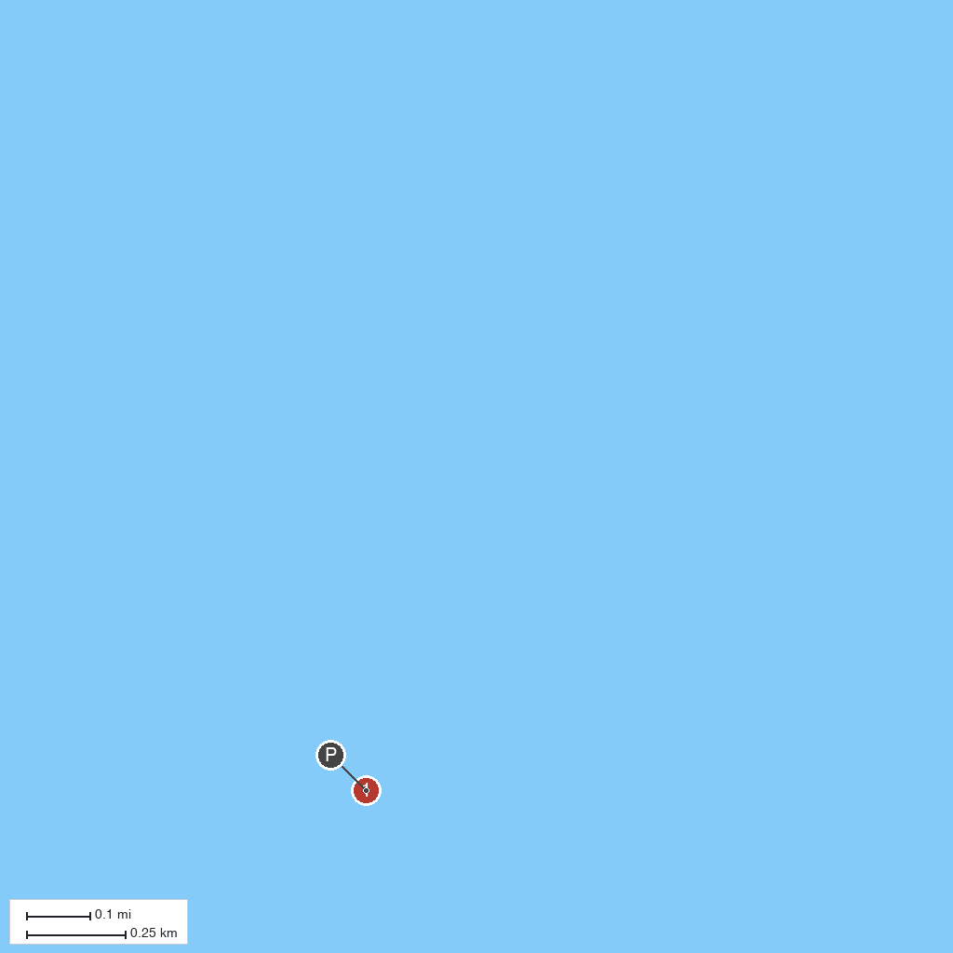
MAP KEY
1. Aldabra Atoll | 2. Picard Island, Aldabra
P. Cruise port / terminal
Map © MapTiler © OpenStreetMap contributors · cruiseports.org

