Alcudia, Mallorca, Spain
Mallorca's medieval north: walled old town, Pollentia's Roman theatre, and kilometres of calm Blue Flag beach — all within easy reach of the pier.
⚓ Docked (Port d'Alcúdia) · 🕒 Typical call: 7-10 hrs · 💶 Euro (EUR) · 🗣️ Catalan / Spanish
✍️ MY DAY IN PORT (FILL IN)
Ship / Date
In port | arrive ______ · all aboard ______
Booked excursion
Notes / meeting point
GETTING ASHORE
- Docking: Berthed at Port d'Alcúdia commercial quay — no tender
- Walk to Center: ~20 min walk or short taxi to Old Town; beach starts at the port
- Best For: History lovers, beach days, cycling the bay, boat excursions
- Don't Miss: Pollentia Roman ruins & theatre just outside the medieval walls
GETTING AROUND
- 🚕 Taxi: €6–€8 — Taxis wait at the port and reach Alcudia Old Town in about 4 minutes. Note a ~€4.40 port surcharge may apply, bringing t
- 📱 Rideshare: ✅ Uber
TOP THINGS TO DO
- Alcudia Old Town & Roman Pollentia — Walk the 14th-century walls, wander cobbled Calle Major, then visit the excavated Roman city of Pollentia — one of the…
- S'Albufera Natural Park — A protected Ramsar wetland a short drive south of the port, home to over 200 bird species.
- Cap de Formentor Boat & Bus Combo — A classic: catch a boat from the port across the bay to Port de Pollença, then a bus up to Mirador Es Colomer and the lighthouse…
- Platja d'Alcúdia Beach Day — One of the finest beaches in Spain — kilometres of fine white sand, shallow calm water, and full Blue Flag facilities.
- Coll Baix & Alcanada Boat Excursion — Board a small boat from the port for secluded Coll Baix — a wild pebbly beach beneath limestone cliffs, reachable only by sea or…
BEST WALKS
- Old Town Walls & Roman Ruins Loop: 2.5 km · 45-60 min · Easy — Start at Porta del Moll, the medieval gate by the Tuesday/Sunday market.
- Port Promenade to Platja d'Alcúdia: 3 km one-way · 35-40 min · Flat — An easy flat stroll south along the waterfront promenade from the cruise pier to the main Blue Flag…
WEATHER · DAYLIGHT · MONEY
Month | High °F | Low °F | Rainy days
May | 74 | 60 | 7
Jul | 88 | 72 | 2
Sep | 82 | 69 | 9
Daylight: May 6:32AM–8:55PM · Jul 6:32AM–9:14PM · Sep 7:28AM–7:55PM
cruiseports.org/alcudia · Confirm terminal & all-aboard time with your ship

Alcudia, Mallorca, Spain — Port Map
Red = walkable sights · Amber = excursions farther out · P = cruise terminal
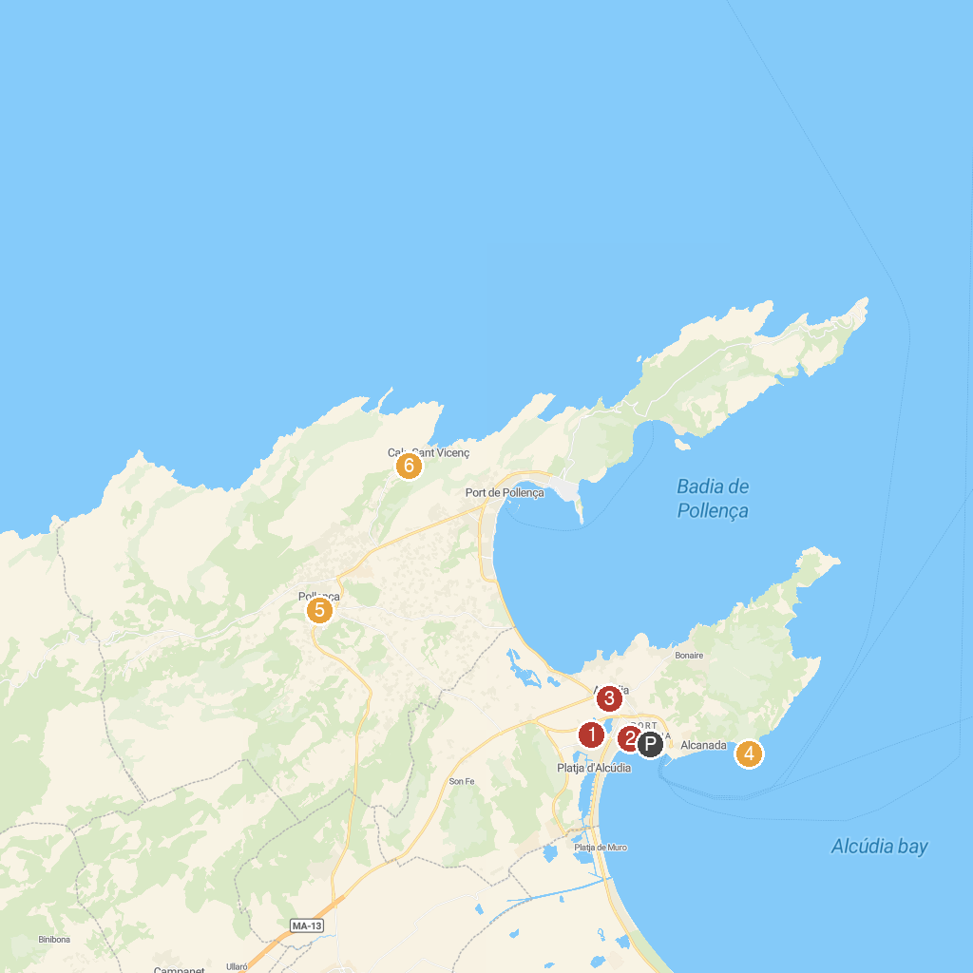
MAP KEY
1. Hidropark Alcúdia | 5. Museu de Pollença
2. My sea Experience | 6. Alzinaret Caves
3. Ruïnes de la ciutat romana de Pollentia | 7. Cases de Son Real
4. Alcanada Lighthouse | 8. Finca Son Real
P. Cruise port / terminal
Map © MapTiler © OpenStreetMap contributors · cruiseports.org

