Albany, New York, USA
New York's capital city delivers an outsized shore day — a riverside pier within walking distance of a jaw-dropping Beaux-Arts capitol, world-class museums, and a real WWII destroyer escort you can board.
⚓ Docked — river pier · 🕒 Typical call: 7-9 hrs · 💵 USD · 🗣️ English · 🏛️ State Capitol & history
✍️ MY DAY IN PORT (FILL IN)
Ship / Date
In port | arrive ______ · all aboard ______
Booked excursion
Notes / meeting point
GETTING ASHORE
- Docking: Deep-water river pier on the Hudson; ships dock directly — no tender
- Walk to center: ~10-15 min on foot to Empire State Plaza and State Capitol
- Best For: American history, architecture, Hudson Valley scenery, museums
- Don't Miss: NY State Capitol tour + USS Slater WWII destroyer escort
GETTING AROUND
- 🚕 Taxi: $8–$12 — Local taxis serve the Albany area with a metered base fare around $5 plus distance. Albany NY Taxi Service and other loc
- 📱 Rideshare: ✅ Uber, Lyft
TOP THINGS TO DO
- New York State Capitol Tour — One of the most elaborate capitol buildings in the U.S., with over 30 years of construction and a stunning million-dollar…
- USS Slater WWII Destroyer Escort — The only restored WWII destroyer escort afloat in the U.S., moored on the Hudson.
- Empire State Plaza & NY State Museum — The dramatic modernist plaza holds the New York State Museum (free, excellent), The Egg performing arts center, and the Corning…
- Albany Institute of History & Art — One of the oldest museums in the U.S., with strong collections on Hudson River School paintings and regional history.
- Hudson River Sightseeing Cruise — Dutch Apple Cruises runs 90-minute river tours from Albany, with views of the capitol skyline, local wildlife including bald…
BEST WALKS
- Capitol Hill Heritage Walk: 1.5 miles · 30-45 min · Easy — A compact loop hitting Albany's greatest hits: the NY State Capitol, the Empire State Plaza, the NY…
- Riverfront Stroll: 1 mile · 20 min · Easy — Walk south along the Hudson riverfront from the pier through the Corning Preserve to the downtown…
WEATHER · DAYLIGHT · MONEY
Month | High °F | Low °F | Rainy days
May | 70 | 49 | 10
Jul | 84 | 64 | 13
Sep | 75 | 57 | 10
Daylight: May 5:32AM–8:10PM · Jul 5:31AM–8:30PM · Sep 6:35AM–7:04PM
cruiseports.org/albany-ny · Confirm terminal & all-aboard time with your ship

Albany, New York, USA — Port Map
Red = walkable sights · Amber = excursions farther out · P = cruise terminal
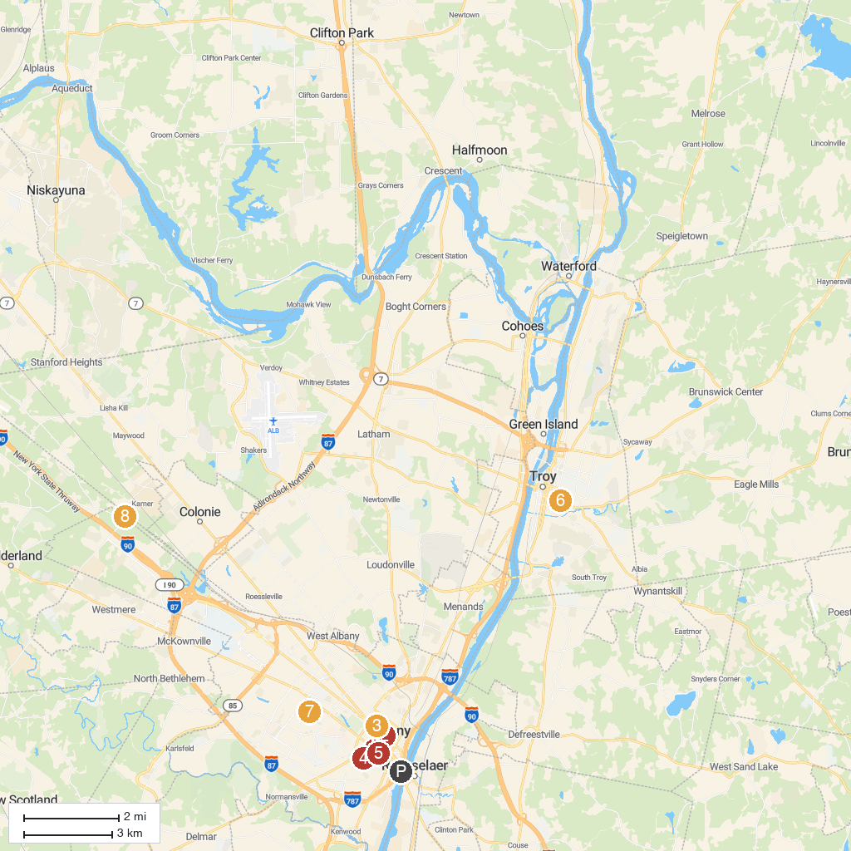
MAP KEY
1. New York State Museum | 5. Cathedral of the Immaculate Conception
2. New York State Capitol | 6. Prospect Park
3. Albany Institute of History & Art | 7. Ridgefield Park
4. Lincoln Park | 8. Albany Pine Bush Preserve
P. Cruise port / terminal
Map © MapTiler © OpenStreetMap contributors · cruiseports.org

