Alang, Gujarat, India
The world's largest ship-breaking yard lines 10 km of Gujarat coastline — a gritty, industrial spectacle where ocean giants are driven aground and dismantled by hand. Not for everyone, but unforgettable.
⚓ Anchor/Tender — no cruise terminal · 🕒 Typical call: 6-8 hrs · 💵 Indian Rupee (INR) · 🗣️ Gujarati / Hindi · 🏭 Industrial tourism
✍️ MY DAY IN PORT (FILL IN)
Ship / Date
In port | arrive ______ · all aboard ______
Booked excursion
Notes / meeting point
GETTING ASHORE
- Docking: No cruise terminal; ships anchor off Bhavnagar or use Bhavnagar Port — Alang reached by road (~50 km)
- Best For: Industrial tourism, maritime history, Gujarat day trips to Palitana temples
- Don't Miss: The coastal road viewpoint overlooking the breaking plots; the massive salvage market
- Restrictions: Entry to active plots requires an NOC; photography inside strictly prohibited
GETTING AROUND
- 🚕 Taxi: ₹800–₹1,200 (~US$10–$14) — Pre-booked local taxis cover the ~49 km journey to Bhavnagar city center in about 45 minutes. Companies like Amy Cab and
TOP THINGS TO DO
- Alang Ship-Breaking Yard Coastal Road Tour — Drive the 10 km coastal stretch alongside the breaking plots.
- Palitana Jain Temples (Shatrunjaya Hill) — One of Jainism's holiest sites, Shatrunjaya Hill is crowned by over 850 intricately carved marble temples.
- Velavadar Blackbuck National Park — One of India's finest grassland reserves, Velavadar is home to a high-density blackbuck population and large flocks of harriers.
- Bhavnagar Old City & Nilambag Palace — Bhavnagar's old bazaar and the heritage Nilambag Palace Hotel — a former royal residence — offer a gentler counterpoint to the…
BEST WALKS
- Alang Coastal Road & Salvage Bazaar: ~2 km on-foot section | Flat | Allow 1 hr — Park near the northern end of the breaking yards and walk the roadside stretch closest to the…
- Bhavnagar Old City Wander: ~1.5 km loop | Easy | Allow 45 min — From Bhavnagar's Gangajalia pier area, walk into the old Darbargadh quarter past the Victoria Park…
WEATHER · DAYLIGHT · MONEY
Month | High °F | Low °F | Rainy days
May | 94 | 81 | 2
Jul | 87 | 80 | 23
Sep | 86 | 78 | 17
Daylight: May 6:03AM–7:12PM · Jul 6:08AM–7:26PM · Sep 6:28AM–6:44PM
cruiseports.org/alang-ship-breaking-yard · Confirm terminal & all-aboard time with your ship

Alang, Gujarat, India — Port Map
Red = walkable sights · Amber = excursions farther out · P = cruise terminal
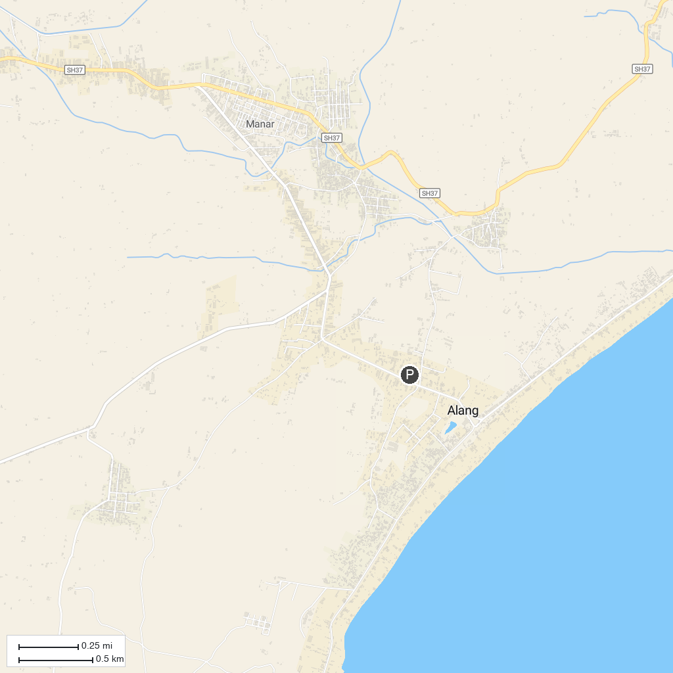
MAP KEY
1. Talaja Caves temple | 2. Gram Yaatra
P. Cruise port / terminal
Map © MapTiler © OpenStreetMap contributors · cruiseports.org

