Al Wajh, Tabuk Region, Saudi Arabia
A quiet Red Sea port town punching far above its size — the highway to Hegra's ancient Nabataean tombs, Saudi Arabia's first UNESCO World Heritage Site, plus pristine coral reefs just offshore.
⚓ Tender port · 🕒 Typical call: 8-10 hrs · 💵 Saudi Riyal (SAR) · 🗣️ Arabic (English in tour context) · 🌡️ Hot & arid year-round
✍️ MY DAY IN PORT (FILL IN)
Ship / Date
In port | arrive ______ · all aboard ______
Booked excursion
Notes / meeting point
GETTING ASHORE
- Docking: Tender to commercial dock, ~5 km from town centre
- Hegra (Madain Salih): ~4 hrs by coach each way; book cruise excursion in advance
- Best For: History buffs, divers, desert adventurers
- Don't Miss: Qasr al-Farid, the 'Lonely Castle' tomb at Hegra — Saudi Arabia's Petra
GETTING AROUND
- 🚕 Taxi: 40–70 SAR (~$11–$19) — Taxis available at the port for the ~5 km ride to the city center. Short in-town rides typically cost 10–20 SAR ($2–$5).
- 📱 Rideshare: ✅ Uber
TOP THINGS TO DO
- Hegra (Madain Salih) — Saudi Arabia's First UNESCO Site — The centrepiece of any Al Wajh call.
- Al Wajh Town Walk & Souk — Explore the corniche past date palms and mosques, browse the local souk for frankincense, camel milk soap, and spices, and see…
- Red Sea Snorkelling & Diving — The reef systems off Al Wajh are among the Red Sea's least-dived — vivid coral gardens, reef fish, and the occasional wreck in…
- Desert Safari & Sandboarding — The golden dunes of the Tabuk region start just inland.
- Island-Hopping in the Al Wajh Lagoon — The shallow lagoon north of town holds a chain of small coral islands with nesting seabirds and isolated beaches.
BEST WALKS
- Al Wajh Corniche & Old Souk: 1.5 km · Flat · 45-60 min — From the dock, taxi or walk into town and stroll the seafront corniche south toward the old market.
WEATHER · DAYLIGHT · MONEY
Month | High °F | Low °F | Rainy days
May | 90 | 75 | 0
Jul | 93 | 80 | 0
Sep | 93 | 80 | 0
Daylight: May 5:47AM–7:13PM · Jul 5:51AM–7:28PM · Sep 6:20AM–6:38PM
cruiseports.org/al-wajh · Confirm terminal & all-aboard time with your ship

Al Wajh, Tabuk Region, Saudi Arabia — Port Map
Red = walkable sights · Amber = excursions farther out · P = cruise terminal
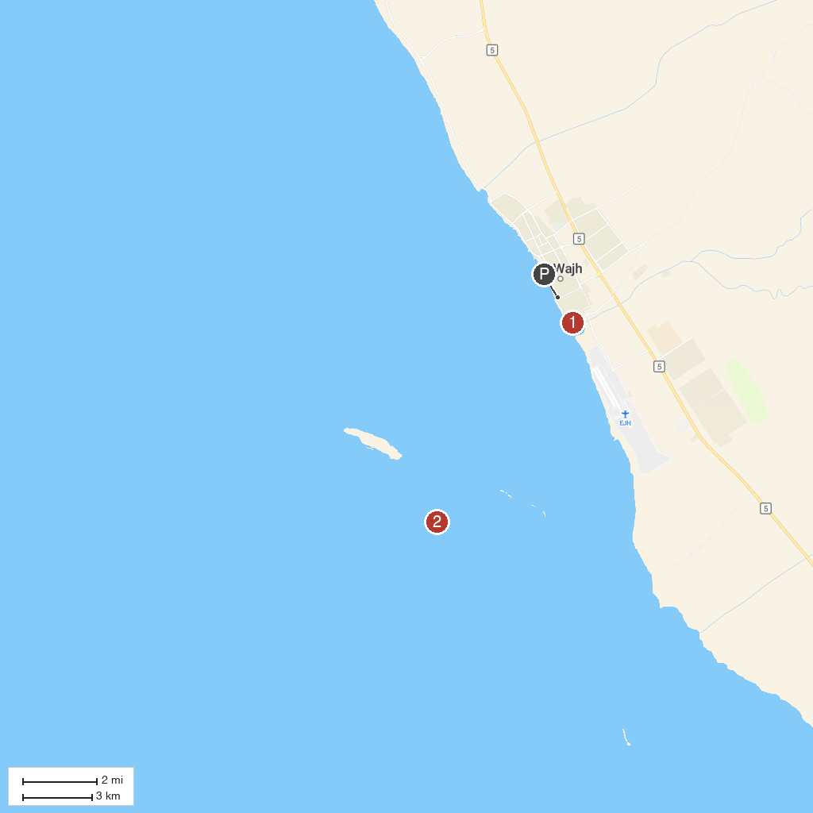
MAP KEY
1. Al Wajh Old Town | 2. Al Wajh Bank
P. Cruise port / terminal
Map © MapTiler © OpenStreetMap contributors · cruiseports.org

