Al-Minya, Upper Egypt, Egypt
The 'Bride of Upper Egypt' sits halfway between Cairo and Luxor, where limestone cliffs cradle Middle Kingdom tombs and the ruins of Akhenaten's heretic capital wait across the river.
⚓ Nile riverbank mooring · 🕒 Typical call: 6-8 hrs · 💵 Egyptian Pound (EGP) · 🗣️ Arabic (guides speak English)
✍️ MY DAY IN PORT (FILL IN)
Ship / Date
In port | arrive ______ · all aboard ______
Booked excursion
Notes / meeting point
GETTING ASHORE
- Docking: River moorings along the Nile corniche; ships tie up alongside the bank or a floating dock
- Walk to center: City center and corniche promenade are steps from the mooring
- Best For: Ancient Egypt — Beni Hasan tombs, Tell el-Amarna, Tuna el-Gabel necropolis
- Don't Miss: Beni Hasan rock-cut tombs — vivid Middle Kingdom paintings 20 km south
GETTING AROUND
- 🚕 Taxi: EGP 20–50 (~/bin/zsh.40–) in-city; EGP 300–400 (~–) for day trips to sites — Taxis are plentiful and cheap for short city hops. Negotiate the fare before you depart — meters are rarely used. Essent
TOP THINGS TO DO
- Beni Hasan Rock-Cut Tombs — Thirty-nine cliff tombs carved by Middle Kingdom provincial governors feature remarkably preserved painted scenes of wrestling…
- Tell el-Amarna — Akhenaten's Lost Capital — Cross the Nile to explore the ruins of Akhetaten, the short-lived city built by pharaoh Akhenaten for his monotheistic sun cult.
- Tuna el-Gabel Necropolis — A vast underground catacomb housing mummified ibises and baboons sacred to Thoth, plus the ornate tomb of Petosiris — one of…
- El-Ashmounein (Hermopolis Magna) — Ruins of the ancient city of Hermopolis, cult center of Thoth.
- Al-Minya Corniche & City Walk — The city's broad Nile promenade is lively and walkable, lined with cafes, gardens, and river views.
BEST WALKS
- Nile Corniche Promenade: 1.5 km · Easy · 20 min one-way — Walk north or south along the corniche from the mooring.
WEATHER · DAYLIGHT · MONEY
Month | High °F | Low °F | Rainy days
May | 96 | 69 | 0
Jul | 101 | 77 | 0
Sep | 97 | 74 | 0
Daylight: May 5:42AM–7:28PM · Jul 5:44AM–7:45PM · Sep 6:23AM–6:44PM
cruiseports.org/al-minya · Confirm terminal & all-aboard time with your ship

Al-Minya, Upper Egypt, Egypt — Port Map
Red = walkable sights · Amber = excursions farther out · P = cruise terminal
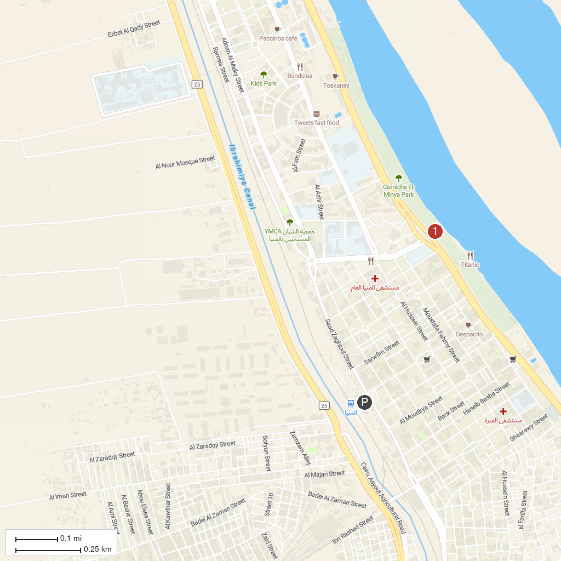
MAP KEY
1. Beni Hasan | 2. Al-Minya Corniche
P. Cruise port / terminal
Map © MapTiler © OpenStreetMap contributors · cruiseports.org

