Akaroa, Banks Peninsula, New Zealand
A French-flavoured harbour village tucked inside an ancient volcanic crater, where the world's rarest dolphins swim just beyond the wharf and the hills roll green to the sea.
⚓ Tender port (anchor & ferry ashore) · 🕒 Typical call: 7–9 hrs · 💵 NZD (New Zealand Dollar) · 🗣️ English · 🐬 Hector's dolphins in the wild
✍️ MY DAY IN PORT (FILL IN)
Ship / Date
In port | arrive ______ · all aboard ______
Booked excursion
Notes / meeting point
GETTING ASHORE
- Docking: Tender only — ships anchor in Akaroa Harbour; 15–20 min ferry to Drummond's Jetty (tender landing while the main Akaroa Wharf is rebuilt, ~2026–2027)
- Walk to Centre: Steps from the tender jetty to village cafes and shops
- Best For: Wildlife (Hector's dolphins, penguins), scenic harbour cruises, French-heritage village strolling
- Don't Miss: A harbour wildlife cruise — Hector's dolphins are unique to New Zealand and abundant here
GETTING AROUND
- 🚕 Taxi: Metered (local taxis); Uber app — Local taxis (including a complimentary town taxi service on cruise days) and Uber are both available. Ideal for those wi
- 📱 Rideshare: ✅ Uber
- 🚌 Hop-on hop-off: ✅
TOP THINGS TO DO
- Hector's Dolphin & Wildlife Harbour Cruise — Board a catamaran to search for Hector's dolphins — the world's smallest and rarest, found only in New Zealand.
- Swim with Hector's Dolphins — A handful of licensed operators offer in-water experiences with wild Hector's dolphins in the harbour.
- Sea Kayaking in the Marine Reserve — Paddle beneath volcanic sea cliffs, through sea caves, and past fur seal colonies in the Akaroa Marine Reserve.
- Little Penguin & Banks Peninsula 4WD Safari — Head into the rugged Banks Peninsula hills by 4WD to visit the Pohatu Marine Reserve — home to the largest little (blue) penguin…
- The Giant's House Garden & Akaroa Village Walk — Stroll Rue Lavaud past French colonial cottages to The Giant's House — a historic homestead with a fantastical garden of mosaic…
BEST WALKS
- Harbourfront Promenade — Jetty to Village: 1 km · 15 min · Flat · No gear needed — Walk south from Drummond's Jetty along Beach Road past heritage buildings, the Akaroa Museum, and…
- Rue Lavaud Heritage Walk: 1.5 km · 20 min · Flat · Self-guided — Follow Rue Lavaud from the waterfront up through the heart of the French-settled village.
WEATHER · DAYLIGHT · MONEY
Month | High °F | Low °F | Rainy days
May | 59 | 47 | 10
Jul | 52 | 41 | 13
Sep | 56 | 44 | 11
Daylight: May 7:35AM–5:12PM · Jul 7:58AM–5:10PM · Sep 6:31AM–6:16PM
cruiseports.org/akaroa · Confirm terminal & all-aboard time with your ship

Akaroa, Banks Peninsula, New Zealand — Port Map
Red = walkable sights · Amber = excursions farther out · P = cruise terminal
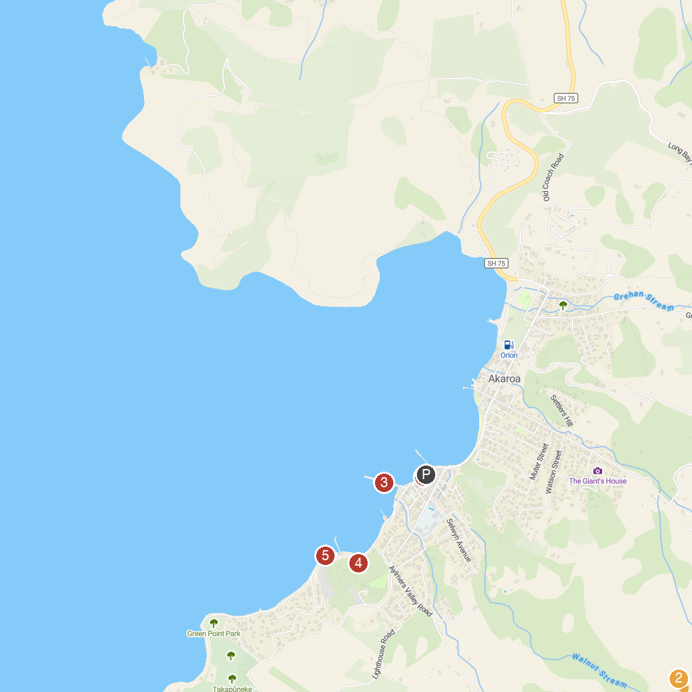
MAP KEY
1. Akaroa Dolphins | 4. Main Wharf
2. Banks Track / Banks Peninsula, NZ | 5. Akaroa Lookout point
3. Little River Gallery | 6. Akaroa Lighthouse
P. Cruise port / terminal
Map © MapTiler © OpenStreetMap contributors · cruiseports.org

