Ajaccio, Corsica, France
Napoleon was born here, and the city hasn't let anyone forget it — but beyond the emperor's shadow lies a genuinely charming Corsican capital with good beaches, great charcuterie, and an Italian art collection that surprises most visitors.
⚓ Docked (Quai L'Herminier) · 🕒 Typical call: 7-9 hrs · 💵 Euro (€) · 🗣️ French / Corsican
✍️ MY DAY IN PORT (FILL IN)
Ship / Date
In port | arrive ______ · all aboard ______
Booked excursion
Notes / meeting point
GETTING ASHORE
- Docking: Alongside at Gare Maritime, Quai L'Herminier — city center is a 5-minute walk
- Walk to Center: ~5 min to Place Foch; Maison Bonaparte another 5 min into the old town
- Best For: Napoleonic history, Corsican cuisine, beaches, Italian Renaissance art
- Don't Miss: Palais Fesch — France's largest collection of Italian paintings outside the Louvre
GETTING AROUND
- 🚕 Taxi: ~€5–12 — Taxi rank immediately outside the terminal. Meters are required; confirm price before boarding. Very short ride to city
- 📱 Rideshare: ✅ Uber
TOP THINGS TO DO
- Maison Bonaparte & Old Town Walk — Napoleon's birthplace at 1 Rue Saint-Charles is now a national museum.
- Palais Fesch — Napoleon's Art Museum — Cardinal Fesch, Napoleon's uncle, assembled Italy's finest Renaissance paintings outside Paris.
- Sanguinaires Islands Boat Trip — Half-day cruise to the red-granite Sanguinaires Islands at the mouth of the Gulf of Ajaccio, crowned by a 19th-century lighthouse.
- Calanques de Piana Scenic Drive — A UNESCO-listed stretch of rose-pink granite cliffs along the west coast, about 70 km north.
- Porticcio Beach by Ferry — A 20-minute ferry from the port drops you at the long golden-sand beach of Porticcio across the gulf — sun loungers, watersports…
BEST WALKS
- Old Town Napoleon Loop: 1.5 km · ~45 min · Easy · Fully flat — A gentle loop through Ajaccio's historic core taking in the main Napoleonic sites.
- Pointe de la Parata Coastal Walk: 4 km round-trip · ~2 hrs · Moderate · Bus to trailhead — Take bus line 5 to the end of the line at Pointe de la Parata, then walk the rocky headland trail…
WEATHER · DAYLIGHT · MONEY
Month | High °F | Low °F | Rainy days
May | 70 | 55 | 8
Jul | 85 | 69 | 3
Sep | 79 | 64 | 8
Daylight: May 6:04AM–8:38PM · Jul 6:03AM–8:58PM · Sep 7:05AM–7:34PM
cruiseports.org/ajaccio · Confirm terminal & all-aboard time with your ship

Ajaccio, Corsica, France — Port Map
Red = walkable sights · Amber = excursions farther out · P = cruise terminal
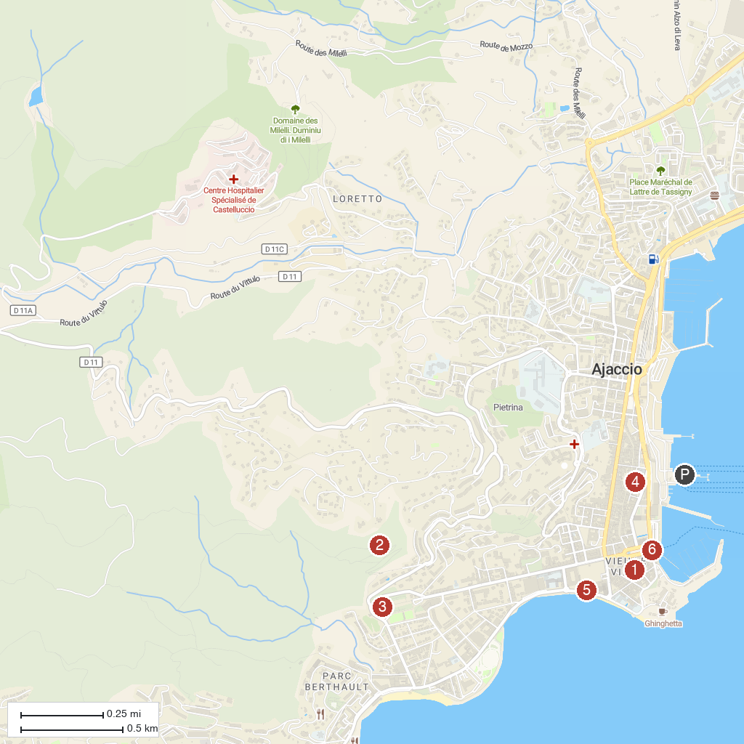
MAP KEY
1. Maison Bonaparte | 4. Fesch Museum
2. Sentier des crêtes - Chjassu d’E Creste | 5. Casino Municipal - Casinò Municipali
3. Monument commémoratif de Napoléon 1er - Munimentu Cummimurativu di Nabuliòne | 6. Ajaccio Vision
P. Cruise port / terminal
Map © MapTiler © OpenStreetMap contributors · cruiseports.org

