Aix-en-Provence, Provence, France
The 'City of a Thousand Fountains' sits 30 km from Marseille, offering Provence at its most refined — shaded boulevards, Cézanne's preserved studio, vibrant morning markets, and streets unchanged since the 17th century.
⚓ Shore excursion from Marseille · 🕒 Typical call: 8–10 hrs · 💶 Euro (EUR) · 🗣️ French
✍️ MY DAY IN PORT (FILL IN)
Ship / Date
In port | arrive ______ · all aboard ______
Booked excursion
Notes / meeting point
GETTING ASHORE
- Getting There: Ships dock at Marseille; Aix is ~30 km away — 30–40 min by taxi/shuttle or 40–45 min by regional train from Marseille St-Charles.
- Walk to Center: Aix old town is compact and flat; Cours Mirabeau to Cathédrale Saint-Sauveur is a 10-min walk.
- Best For: Art lovers (Cézanne), market shoppers, walkers who love fountain-dotted plazas and sidewalk cafés.
- Don't Miss: Cours Mirabeau boulevard, Cézanne's Atelier on Lauves hill, and calisson candy from a local confiserie.
GETTING AROUND
- 🚕 Taxi: €90–€100 — Taxis from the Marseille cruise port to Aix-en-Provence cost roughly €90–€100 one-way, including tolls. A double-tariff
- 📱 Rideshare: ✅ Uber
TOP THINGS TO DO
- Cézanne's Atelier & the Painter's Trail — Follow brass 'C' medallions embedded in Aix's sidewalks to trace Paul Cézanne's life — his birthplace, the Musée Granet, and his…
- Cours Mirabeau & Old Town Stroll — Aix's grand boulevard is lined with plane trees, hot-spring fountains, and 17th-century mansions.
- Provençal Market & Calisson Tasting — On Tuesdays, Thursdays, and Saturdays the Cours and surrounding squares fill with vendors selling flowers, produce, fabrics, and…
- Aix + Calanques Combo — Many operators pair Aix with the dramatic limestone calanques near Cassis — turquoise sea inlets accessible by boat or on foot.
- Hôtel de Caumont Art Center — An 18th-century private mansion restored as a prestigious art venue with temporary exhibitions and a garden café.
BEST WALKS
- Cours Mirabeau to Cathédrale Saint-Sauveur: 1.2 km · ~20 min · Easy — Walk the full length of Cours Mirabeau past the Fontaine de la Rotonde and King René's Fountain…
- Mazarin Quarter & Four Dolphins Fountain: 0.8 km · ~15 min · Easy — South of Cours Mirabeau, the 17th-century Mazarin Quarter is quieter and more aristocratic.
- Uphill to Cézanne's Studio: 1.5 km · ~20 min uphill · Moderate — From the old town, follow the brass Cézanne medallions north up Avenue Paul Cézanne to his Atelier…
WEATHER · DAYLIGHT · MONEY
Month | High °F | Low °F | Rainy days
May | 72 | 53 | 9
Jul | 88 | 66 | 2
Sep | 78 | 59 | 6
Daylight: May 6:13AM–8:56PM · Jul 6:11AM–9:16PM · Sep 7:17AM–7:47PM
cruiseports.org/aix-en-provence · Confirm terminal & all-aboard time with your ship

Aix-en-Provence, Provence, France — Port Map
Red = walkable sights · Amber = excursions farther out · P = cruise terminal
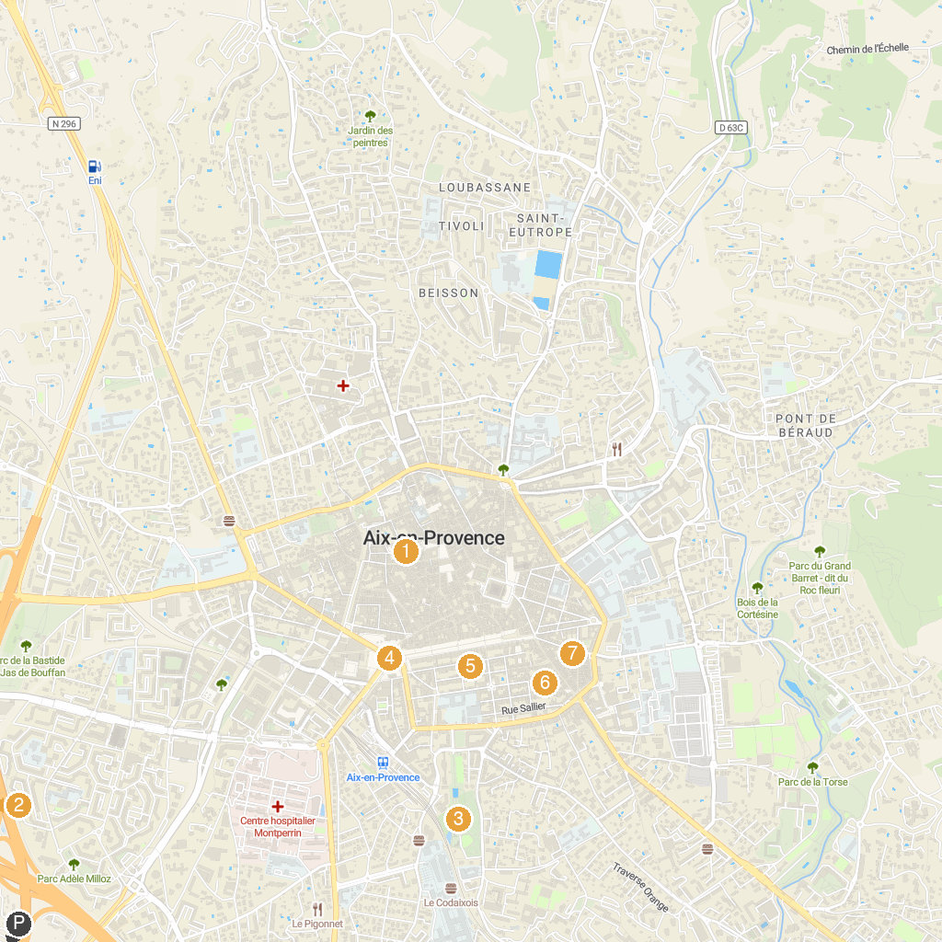
MAP KEY
1. Place des Cardeurs | 5. Fontaine de la Rotonde
2. Fondation Vasarely | 6. Hôtel de Caumont
3. The Village des Automates | 7. Musée Granet
4. Parc Jourdan | 8. Granet XXe, chapelle des Pénitents blancs
P. Cruise port / terminal
Map © MapTiler © OpenStreetMap contributors · cruiseports.org

