Airlie Beach, Queensland, Australia
The gateway to 74 tropical islands — tender ashore to a small resort town, then sail or fly out to Whitehaven Beach's dazzling silica sands and the technicolour corals of the Great Barrier Reef.
⚓ Tender port (ships anchor offshore) · 🕒 Typical call: 7–9 hrs · 💵 Australian Dollar (AUD) · 🗣️ English
✍️ MY DAY IN PORT (FILL IN)
Ship / Date
In port | arrive ______ · all aboard ______
Booked excursion
Notes / meeting point
GETTING ASHORE
- Docking: Tender to Port of Airlie
- Walk to center: 5 min from tender dock
- Best For: Whitehaven Beach · Reef snorkelling
- Don't Miss: Hill Inlet lookout
GETTING AROUND
- 🚕 Taxi: AUD $8–14 — Short ride to town centre. Metered Regional Queensland fares: ~AUD $8–10 weekday daytime, ~AUD $10–14 evenings/weekends.
- 📱 Rideshare: ✅ Uber
TOP THINGS TO DO
- Whitehaven Beach & Hill Inlet — One of the world's finest beaches — 7 km of 98% pure silica sand on Whitsunday Island, blinding white and squeaky underfoot.
- Great Barrier Reef Snorkel & Dive — Day trips to the outer reef — Hardy Reef, Hook Reef, or Knoll — put you on coral bommies alive with turtles, reef sharks…
- Whitsunday Islands Sailing — Charter a crewed yacht or join a group sailing tour through the 74 islands — anchoring in secluded bays, snorkelling reefs, and…
- Seaplane or Helicopter Reef Flight — A scenic flight over the Heart Reef (a naturally heart-shaped coral formation), Hill Inlet, and the outer reef gives a…
- Airlie Beach Lagoon & Town — The free foreshore lagoon is a stinger-safe saltwater swimming pool right on the beach — perfect if you're skipping an island trip.
BEST WALKS
- Foreshore Promenade & Airlie Beach Lagoon: ~2 km · 45 min · easy — Walk the Bicentennial Walkway from the Port of Airlie marina along the foreshore past the free…
- Conway National Park — Whitsunday Passage Lookout: ~3.6 km return · 1.5 hrs · moderate — A 10-minute drive from town leads to the Conway NP trailhead.
WEATHER · DAYLIGHT · MONEY
Month | High °F | Low °F | Rainy days
May | 75 | 68 | 10
Jul | 71 | 63 | 6
Sep | 76 | 67 | 4
Daylight: May 6:26AM–5:35PM · Jul 6:40AM–5:41PM · Sep 6:01AM–5:59PM
cruiseports.org/airlie-beach · Confirm terminal & all-aboard time with your ship

Airlie Beach, Queensland, Australia — Port Map
Red = walkable sights · Amber = excursions farther out · P = cruise terminal
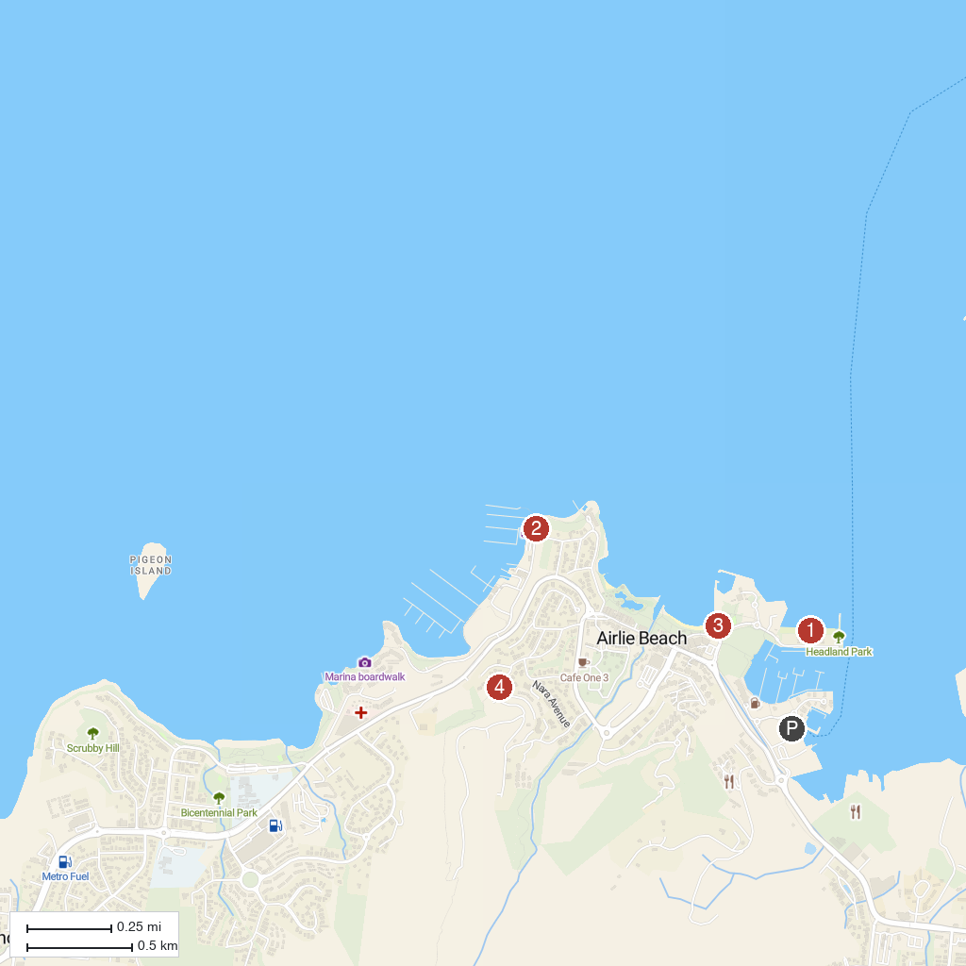
MAP KEY
1. Boathaven Beach | 4. Honeyeater Lookout Trail
2. Providence Whitsunday Sailing | 5. Cruise Whitsundays
3. Whitsunday Saturday Markets
P. Cruise port / terminal
Map © MapTiler © OpenStreetMap contributors · cruiseports.org

