Aigues-Mortes, Occitanie, France
A perfectly preserved Crusader city rising from the salt marshes — Aigues-Mortes offers medieval walls you can walk end to end, flamingo-dotted wetlands, and some of the most photogenic pink salt pans in Europe.
⚓ Small marina / river cruise pier · 🕒 Typical call: 6-8 hrs · 💶 Euro (€) · 🗣️ French
✍️ MY DAY IN PORT (FILL IN)
Ship / Date
In port | arrive ______ · all aboard ______
Booked excursion
Notes / meeting point
GETTING ASHORE
- Docking: Small marina inside the canal — accessible to river cruise barges and small expedition ships only; ocean cruise guests arrive from Sète by coach
- Walk to center: 2 min from the marina to the medieval gate
- Best For: Medieval history, Camargue nature, pink salt marshes, flamingo spotting
- Don't Miss: Walking the full 1.6 km circuit atop the ramparts for views over the salt pans
GETTING AROUND
- 🚕 Taxi: €20–30 — Regulated taxis connect Port Camargue (approx. 8–9 km away) to the Aigues-Mortes town center. Metered fares apply; book
- 📱 Rideshare: ✅ Uber
TOP THINGS TO DO
- Walk the Medieval Ramparts — The 1.6 km circuit atop the 13th-century walls is the port's headline attraction.
- Tour de Constance — The great circular tower built around 1242 by Louis IX served as lighthouse, watchtower, and prison.
- Salins du Midi Salt Marshes Tour — A short ride from the city gates, the Salins du Midi have been harvesting salt since ancient times.
- Camargue Jeep or Horseback Safari — The Camargue wetlands begin right at the city's edge.
- Place Saint-Louis & Church of Notre-Dame des Sablons — The central square anchors the old town, its statue of Saint Louis surveying the medieval grid.
BEST WALKS
- Ramparts Circuit: 1.6 km loop | Easy | ~45 min — Enter at the Tour de Constance ticket office and walk the full perimeter of the walls.
- Old Town Grid Walk: ~1 km loop | Easy | 30-45 min — Explore the planned medieval grid from Place Saint-Louis out to the main shopping street (Grande…
WEATHER · DAYLIGHT · MONEY
Month | High °F | Low °F | Rainy days
May | 72 | 57 | 8
Jul | 85 | 70 | 3
Sep | 77 | 63 | 6
Daylight: May 6:18AM–9:01PM · Jul 6:16AM–9:21PM · Sep 7:22AM–7:53PM
cruiseports.org/aigues-mortes · Confirm terminal & all-aboard time with your ship

Aigues-Mortes, Occitanie, France — Port Map
Red = walkable sights · Amber = excursions farther out · P = cruise terminal
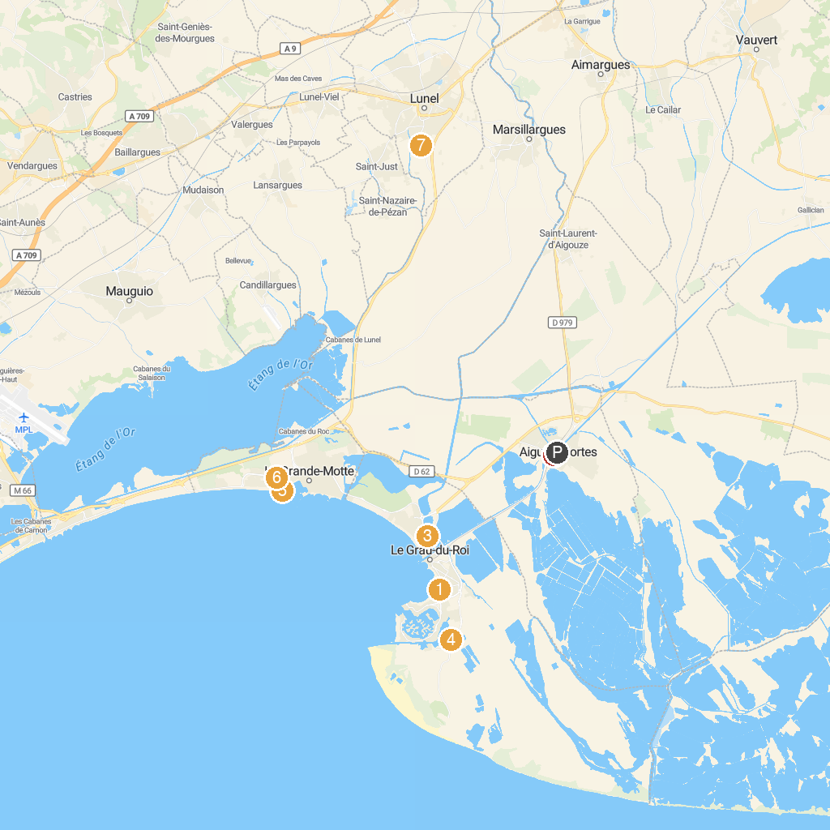
MAP KEY
1. Seaquarium Institut Marin | 5. Sunset Beach
2. Towers and Walls of Aigues-Mortes | 6. Parc gonflable Kangoo
3. Base Nautique Intercommunale | 7. Arboretum de Lunel
4. Cabaret Equestre de Camargue | 8. Centre de découverte du Scamandre
P. Cruise port / terminal
Map © MapTiler © OpenStreetMap contributors · cruiseports.org

