Agilkia Island, Aswan, Egypt
A tiny island in the Nile reservoir that holds one of Egypt's most beloved temple complexes — the sanctuary of Isis, saved stone by stone from rising floodwaters and rebuilt here in a UNESCO feat of rescue archaeology.
⚓ Motorboat transfer (no direct pier) · 🕒 Typical call: 4-6 hrs · 💵 Egyptian Pound (EGP) · 🗣️ Arabic · 🌡️ Hot desert climate — shade is scarce
✍️ MY DAY IN PORT (FILL IN)
Ship / Date
In port | arrive ______ · all aboard ______
Booked excursion
Notes / meeting point
GETTING ASHORE
- Docking: Nile cruise ships dock at Shellal/Marina Philae; guests reach Agilkia by small motorboat (~10 min)
- Walk to center: The island itself is compact — all temples within a 10-min walk of the landing dock
- Best For: Ancient Egyptian temples, Ptolemaic architecture, hieroglyphs, Nile photography
- Don't Miss: Trajan's Kiosk at sunset and the Sound & Light Show on evening calls
GETTING AROUND
- 🚕 Taxi: 70–100 EGP one way — A taxi from Aswan city center to Marina Philae (Shellal Dock) takes roughly 20 minutes. Agree on a price before you get
TOP THINGS TO DO
- Philae Temple Complex Self-Guided Walk — Explore the entire Ptolemaic complex at your own pace: First Pylon, open colonnaded courtyard, Temple of Isis, inner Sanctuary…
- Egyptologist-Guided Temple Tour — A licensed Egyptologist deciphers the myths of Isis and Osiris carved into the pylon walls, explains the UNESCO relocation…
- Sound & Light Show at Philae — On evening calls, the temple is dramatically lit and narrated — the story of Isis, Osiris, and Horus told through coloured…
- Aswan High Dam & Nile Panorama — Combine the temple visit with a stop at the Aswan High Dam, just minutes away by road.
- Nubian Village & Museum — Head into Aswan to visit the Nubian Museum (Egypt's finest collection of Nubian artefacts) or cross to a Nubian village on…
BEST WALKS
- Philae Temple Island Circuit: ~1 km | 30-45 min | Easy — From the boat landing, follow the path past the outer colonnade to the First Pylon entrance.
WEATHER · DAYLIGHT · MONEY
Month | High °F | Low °F | Rainy days
May | 103 | 76 | 0
Jul | 106 | 81 | 0
Sep | 104 | 78 | 0
Daylight: May 6:05AM–7:23PM · Jul 6:10AM–7:38PM · Sep 6:34AM–6:51PM
cruiseports.org/agilkia-island · Confirm terminal & all-aboard time with your ship

Agilkia Island, Aswan, Egypt — Port Map
Red = walkable sights · Amber = excursions farther out · P = cruise terminal
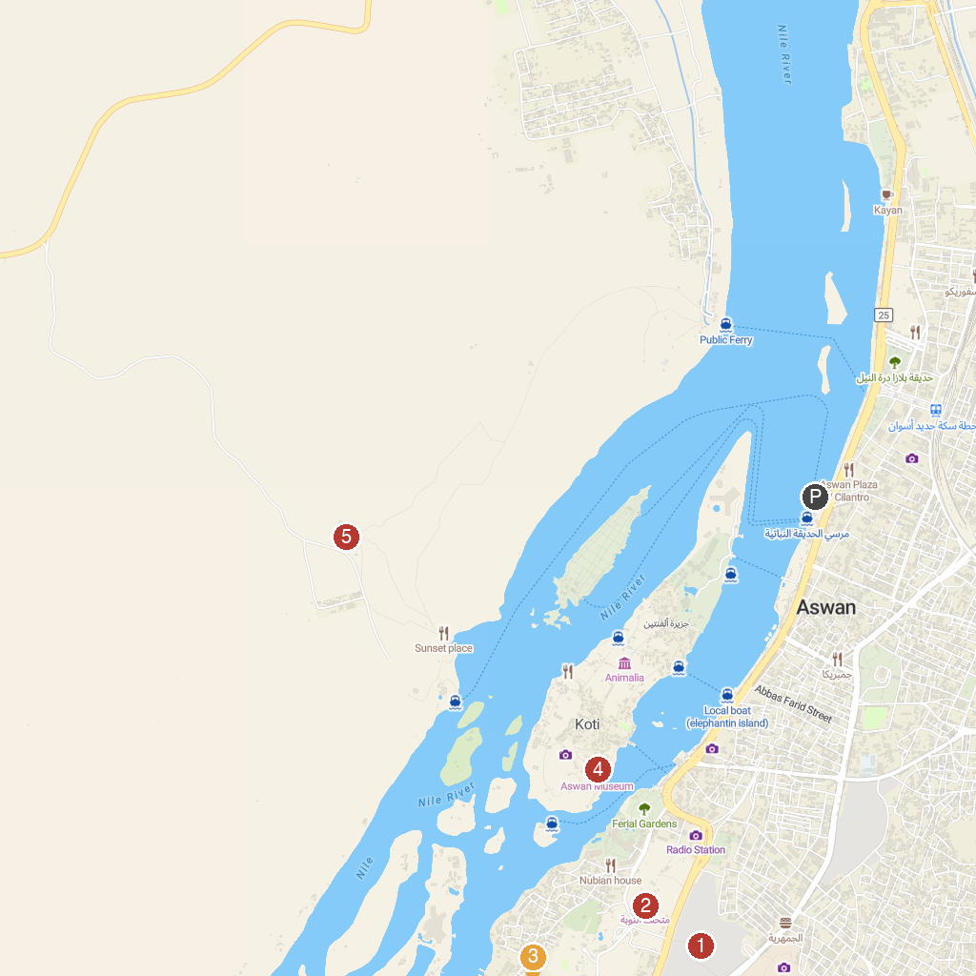
MAP KEY
1. Kalabsha Temple | 5. Nubian Museum
2. Beit el-Wali | 6. Philae Temple
3. Assuão-The High Dam | 7. Aswan Museum
4. Fatimid Cemetery | 8. Monastery of St. Simeon
P. Cruise port / terminal
Map © MapTiler © OpenStreetMap contributors · cruiseports.org

