Agats, South Papua, Indonesia
Rising from tidal flats on a network of wooden boardwalks, Agats is the administrative heart of the Asmat people — one of the world's great woodcarving cultures. Few cruise itineraries reach here; those that do offer something genuinely rare.
⚓ Tender port (no cruise pier) · 🕒 Typical call: 6-8 hrs · 💵 Indonesian Rupiah (IDR) · 🗣️ Indonesian / Asmat · 🌿 Expedition ships only
✍️ MY DAY IN PORT (FILL IN)
Ship / Date
In port | arrive ______ · all aboard ______
Booked excursion
Notes / meeting point
GETTING ASHORE
- Docking: Tender only; conditions depend on tides and weather
- Walk to center: Boardwalks from tender landing lead directly into town
- Best For: Indigenous culture, woodcarving art, remote adventure
- Don't Miss: Asmat Museum of Culture and Progress
GETTING AROUND
- 🚕 Taxi: Negotiable — Water taxis connect Agats to the nearby Ewer airstrip (about 45 min) and outlying Asmat villages. Arrange locally at the
- 📱 Rideshare: ✅ Maxim
TOP THINGS TO DO
- Asmat Museum of Culture and Progress — Founded in 1973 by missionary Father Frank Trenkenschuh, this world-class collection holds over 1,200 Asmat artifacts — ancestor…
- Asmat Woodcarvers Workshop Visit — Watch master carvers shape canoes, bisj poles, and ceremonial figures from ironwood.
- Asmat Village River Expedition — Zodiac or speedboat trip through mangrove-lined channels to outlying villages like Syuru.
- Boardwalk Town Walk — Wander Agats's own streets — which happen to be elevated wooden walkways suspended above tidal mud.
BEST WALKS
- Agats Boardwalk Loop: ~1.5 km · 45 min · Easy — From the tender landing, follow the main boardwalk north past the local market and tribal monument…
WEATHER · DAYLIGHT · MONEY
Month | High °F | Low °F | Rainy days
May | 85 | 76 | 27
Jul | 83 | 74 | 23
Sep | 84 | 74 | 24
Daylight: May 5:48AM–5:39PM · Jul 5:58AM–5:48PM · Sep 5:40AM–5:44PM
cruiseports.org/agats · Confirm terminal & all-aboard time with your ship

Agats, South Papua, Indonesia — Port Map
Red = walkable sights · Amber = excursions farther out · P = cruise terminal
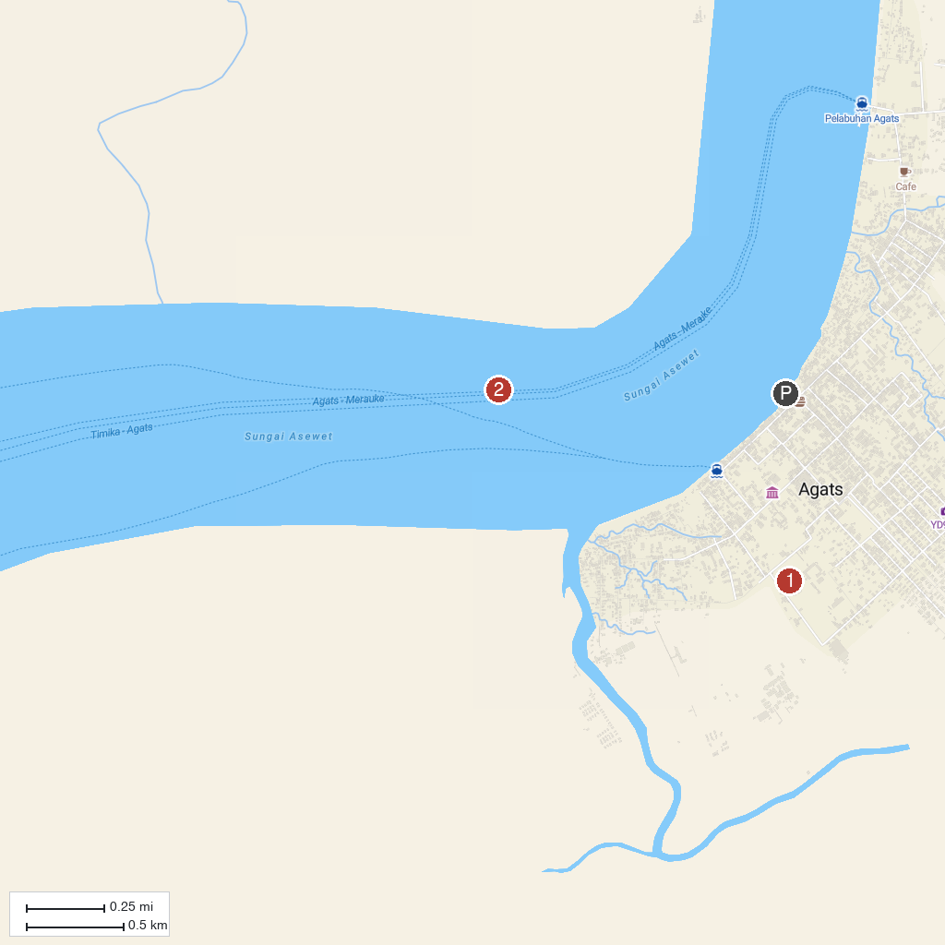
MAP KEY
1. Asmat Museum of Culture and Progress | 2. Agats
P. Cruise port / terminal
Map © MapTiler © OpenStreetMap contributors · cruiseports.org

