Agadir, Morocco
Morocco's sun-soaked Atlantic resort and gateway to the Souss valley
⚓ Port-based · 🏖️ Beach Resort · 🇲🇦 Moroccan Culture · ☀️ Sunny Destination
✍️ MY DAY IN PORT (FILL IN)
Ship / Date
In port | arrive ______ · all aboard ______
Booked excursion
Notes / meeting point
GETTING ASHORE
- Currency: Moroccan Dirham (MAD)
- Language: Arabic, French, Berber
- Time Zone: UTC+1
- Climate: Mediterranean/Subtropical
GETTING AROUND
- 🚕 Taxi: $3–5 USD (30–50 MAD) — Small cream-colored metered taxis wait at the port gate. Insist on the meter or agree a fare upfront; the city center an
- 📱 Rideshare: ✅ inDrive
- 🚌 Hop-on hop-off: ✅
TOP THINGS TO DO
- Souk El Had — Visit one of Africa's largest markets, a labyrinth of stalls selling spices, leather goods, leather and traditional Moroccan…
- Agadir Oufella — Ascend to the ruins of the old fortress on the hill for the most iconic panoramic views of the Agadir bay and city.
- Paradise Valley — A scenic trip into the Atlas Mountains to see natural rock pools and waterfalls in a lush valley setting.
- Agadir Beach — Enjoy the wide, golden sands of the Atlantic coast, perfect for sunbathing, surfing, or a seaside stroll.
BEST WALKS
- City Center Stroll: Shopping & Dining — Take a taxi to the city center and walk through the modern streets, visiting local cafes and…
- Beachfront Promenade: Beach & Ocean — Walk along the wide promenade that separates the beach from the city, offering a relaxing view of…
- Kasbah Agadir: History & Culture — Visit the reconstructed fortress and museum to learn about the city's history and the 1960…
WEATHER · DAYLIGHT · MONEY
Month | High °F | Low °F | Rainy days
May | 78 | 62 | 1
Jul | 83 | 67 | 0
Sep | 81 | 66 | 0
Daylight: May 6:44AM–8:25PM · Jul 6:46AM–8:41PM · Sep 7:23AM–7:43PM
cruiseports.org/agadir · Confirm terminal & all-aboard time with your ship

Agadir, Morocco — Port Map
Red = walkable sights · Amber = excursions farther out · P = cruise terminal
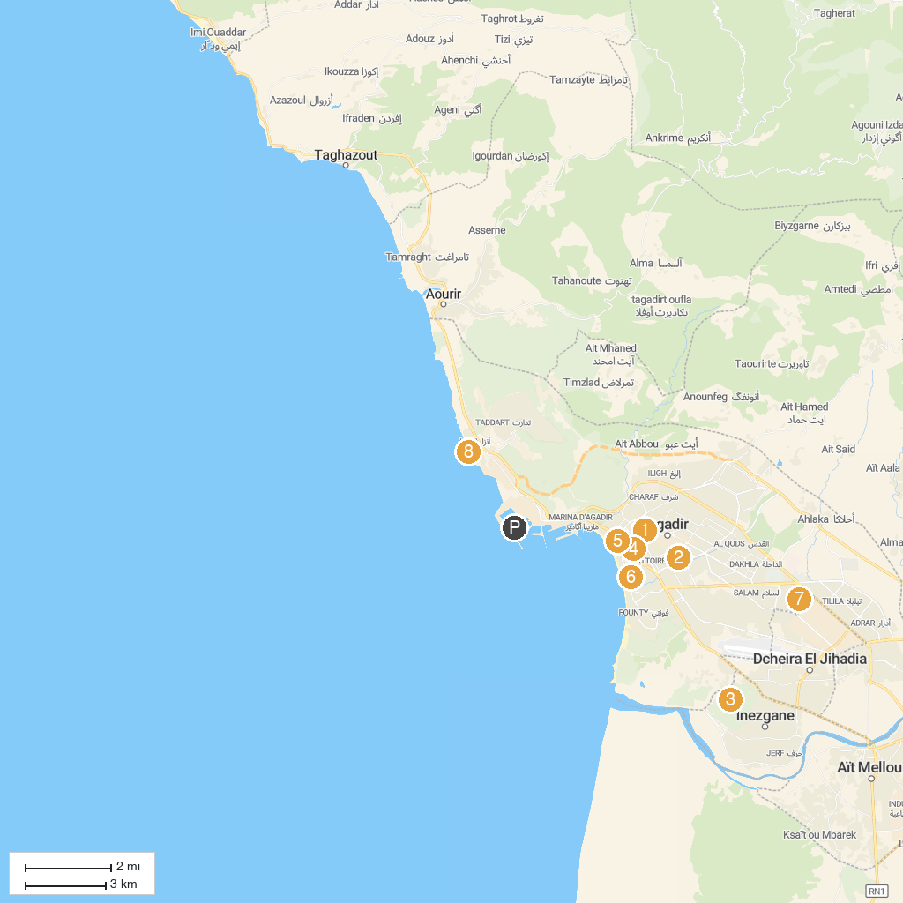
MAP KEY
1. Mohamed V mosque Mezquita | 5. Agadir Birds Valley
2. Souk El Had | 6. Casino Le Mirage
3. Golf Les Dunes, Agadir | 7. ADI Tours
4. Agadir Art Museum | 8. Anza Beach
P. Cruise port / terminal
Map © MapTiler © OpenStreetMap contributors · cruiseports.org

