Ærø Island, South Funen Archipelago, Denmark
A slow-travel island of cobblestone lanes and thatched houses, Ærø rewards wanderers with ships-in-bottles museums, moraine cliffs, and a free bus that crosses the whole island in an hour.
⚓ Tender port · 🕒 Typical call: 6-8 hrs · 💴 Danish Krone (DKK) — cards widely accepted · 🗣️ Danish (English widely spoken)
✍️ MY DAY IN PORT (FILL IN)
Ship / Date
In port | arrive ______ · all aboard ______
Booked excursion
Notes / meeting point
GETTING ASHORE
- Docking: Tender to Ærøskøbing or Marstal quay
- Walk to centre: 2-5 min from tender landing
- Best For: Cycling, historic architecture, maritime history
- Don't Miss: Ships-in-Bottle Museum, Voderup Klint cliffs
GETTING AROUND
- 🚕 Taxi: Varies — Aero Taxi provides local taxi service across the island. Useful for reaching remote areas or for passengers with mobilit
- 📱 Rideshare: ❌ not available
TOP THINGS TO DO
- Ærøskøbing Old Town Walk — Wander Brogade and its side alleys, lined with half-timbered houses from the 1600s–1700s.
- Island Cycle Route — Rent a bike at the tender dock and pedal coastal paths through rolling fields and thatched villages.
- Marstal Maritime Museum — Denmark's premier small-ship maritime museum spans 37 exhibits across five buildings and traces Marstal's seafaring legacy from…
- Voderup Klint Coastal Cliffs — Unique 'stepped' moraine cliffs on the island's southwest coast drop dramatically to the sea.
- Skjoldnæs Lighthouse — Built in 1881 from cut Bornholm granite at the island's northern tip near Søby, this 22-metre lighthouse is a landmark worth the…
BEST WALKS
- Ærøskøbing Historic Centre Loop: 1.5 km · 30-45 min · Easy — From the harbour quay, follow Søndergade into the old town, turn onto Brogade for the…
- Ærøskøbing Beach Huts Walk: 2 km round-trip · 40 min · Easy — Head west from the tender quay along the waterfront to Vesterstrand beach, where rows of colourful…
WEATHER · DAYLIGHT · MONEY
Month | High °F | Low °F | Rainy days
May | 59 | 49 | 10
Jul | 69 | 60 | 13
Sep | 64 | 57 | 10
Daylight: May 5:11AM–9:19PM · Jul 5:00AM–9:46PM · Sep 6:51AM–7:34PM
cruiseports.org/aero-island-denmark · Confirm terminal & all-aboard time with your ship

Ærø Island, South Funen Archipelago, Denmark — Port Map
Red = walkable sights · Amber = excursions farther out · P = cruise terminal
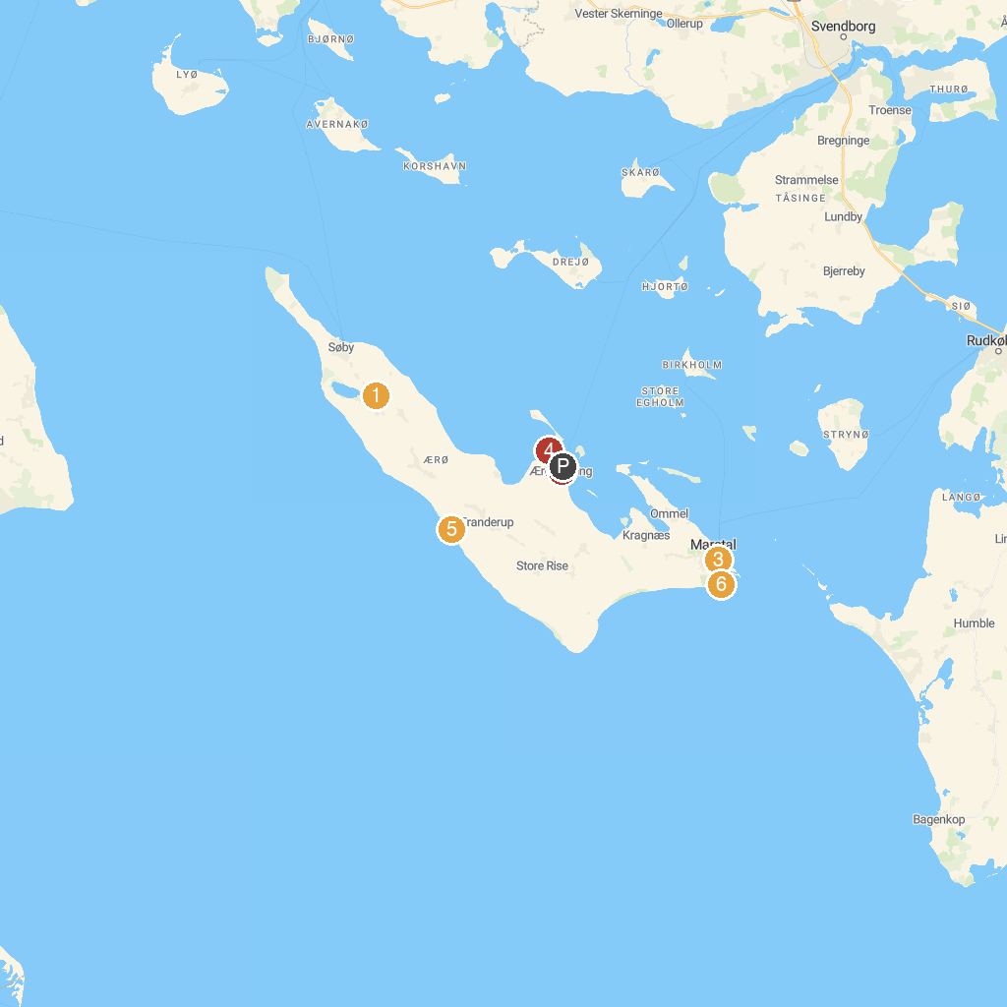
MAP KEY
1. Søbygård | 4. Badehuse ved Vestre Strandvej
2. Flaske-Peters Samling | 5. Voderup Klint
3. Marstal Søfartsmuseum | 6. Badehusene i Marstal
P. Cruise port / terminal
Map © MapTiler © OpenStreetMap contributors · cruiseports.org

