Aegina Island, Saronic Gulf, Greece
A sun-drenched Saronic gem with a perfectly preserved Doric temple, world-famous pistachios, and a waterfront that invites you to slow down over fresh seafood and ouzo.
⚓ Tender or docked (smaller ships) · 🕒 Typical call: 6-8 hrs · 💶 Euro (EUR) · 🗣️ Greek
✍️ MY DAY IN PORT (FILL IN)
Ship / Date
In port | arrive ______ · all aboard ______
Booked excursion
Notes / meeting point
GETTING ASHORE
- Docking: Small quay in Aegina Town; larger ships tender, smaller cruise ships & superyachts dock stern-to
- Walk to center: Immediate — port opens directly onto the waterfront promenade
- Best For: Ancient history, pistachio shopping, Greek island atmosphere
- Don't Miss: Temple of Aphaia (480 BC) and a bag of fresh PDO Aegina pistachios
GETTING AROUND
- 🚕 Taxi: €10–€20 — Taxis queue at the harbor exit in Aegina Town with posted fixed fares. Agios Nektarios ~€10, Agia Marina ~€18, Perdika ~
- 📱 Rideshare: ❌ not available
TOP THINGS TO DO
- Temple of Aphaia — One of Greece's best-preserved ancient temples, built around 480 BC on a pine-forested hill overlooking Agia Marina.
- Temple of Apollo (Kolona) & Archaeological Museum — A single standing column from the 6th-century BC Temple of Apollo marks this site just a 10-minute walk from the port.
- Moni Island Day Trip — A 10-minute boat ride from the fishing village of Perdika takes you to uninhabited Moni Island — crystal-clear waters perfect for…
- Aegina Town & Pistachio Shopping — Wander the harbourfront, the morning fish market, and the backstreets lined with neoclassical mansions.
- Paleochora (Medieval Ghost Town) — Aegina's former medieval capital sits on an inland hill with over 30 Byzantine-era chapels scattered across the hillside.
BEST WALKS
- Waterfront to Temple of Apollo (Kolona): 1.5 km round-trip | Easy | 30-45 min — From the port, walk north along the harbour promenade past fishing boats and waterfront cafes to…
- Aegina Town Waterfront Stroll: 1 km | Easy | 30 min — A leisurely circuit from the ferry pier south along the promenade, past pistachio shops, the fish…
WEATHER · DAYLIGHT · MONEY
Month | High °F | Low °F | Rainy days
May | 69 | 64 | 3
Jul | 84 | 77 | 0
Sep | 79 | 73 | 3
Daylight: May 6:16AM–8:29PM · Jul 6:16AM–8:47PM · Sep 7:08AM–7:33PM
cruiseports.org/aegina-island · Confirm terminal & all-aboard time with your ship

Aegina Island, Saronic Gulf, Greece — Port Map
Red = walkable sights · Amber = excursions farther out · P = cruise terminal
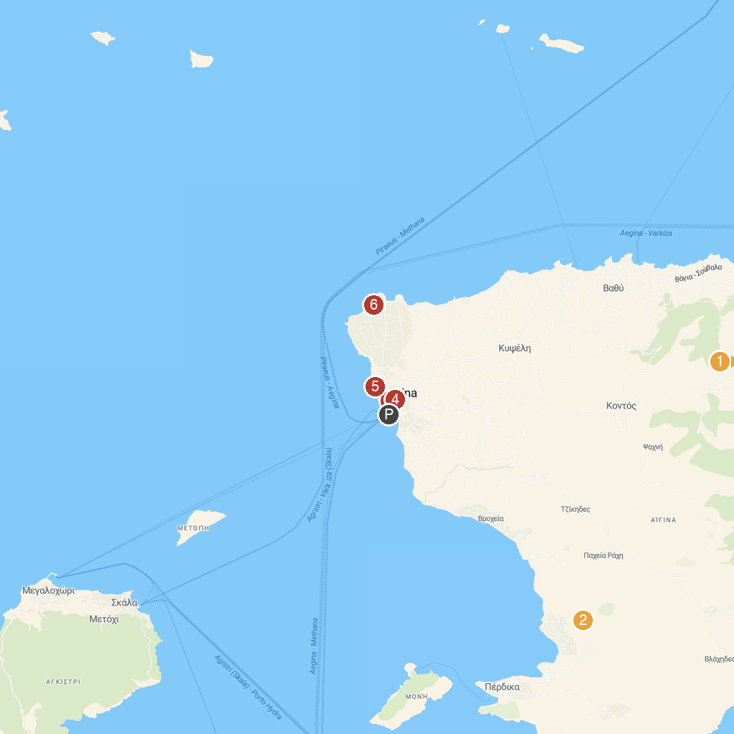
MAP KEY
1. Temple of Aphaia | 4. Tower of Markellos
2. Ancient Olive Grove (Eleonas) | 5. Archaeological Museum of Aegina
3. Umbrellas of Aegina | 6. Christos Kapralos Museum
P. Cruise port / terminal
Map © MapTiler © OpenStreetMap contributors · cruiseports.org

