Acajutla, Sonsonate, El Salvador
El Salvador's main Pacific port punches above its industrial looks — a day here unlocks UNESCO ruins, volcanic hikes, and the vivid Ruta de las Flores coffee towns.
⚓ Docked at pier · 🕒 Typical call: 8-10 hrs · 💵 USD (no exchange needed) · 🗣️ Spanish · 🌋 Volcano & archaeology country
✍️ MY DAY IN PORT (FILL IN)
Ship / Date
In port | arrive ______ · all aboard ______
Booked excursion
Notes / meeting point
GETTING ASHORE
- Docking: Ships dock at Puerto de Acajutla, a commercial pier — no tendering
- Walk to center: Acajutla town is ~10 min walk, but key sights are 45–90 min inland by bus or taxi
- Best For: Pre-Columbian ruins, Ruta de las Flores colonial towns, volcanic landscapes
- Don't Miss: Tazumal ruins or Joya de Cerén (UNESCO) — El Salvador's crown archaeological jewels
GETTING AROUND
- 🚕 Taxi: $30–60 USD (round trip) — Taxis wait outside the port gates. Fares are unmetered — negotiate a round-trip price before departure. Few drivers spea
TOP THINGS TO DO
- Tazumal Mayan Ruins — One of El Salvador's most impressive pre-Columbian sites, Tazumal features stepped pyramid structures from the Classic Maya…
- Joya de Cerén — Pompeii of the Americas — UNESCO World Heritage site where a pre-Hispanic farming village was perfectly sealed under volcanic ash in 590 AD.
- Ruta de las Flores — A winding route through colonial highland towns — Juayúa, Ataco, Nahuizalco — known for colorful murals, artisan markets, coffee…
- Izalco Volcano & Cerro Verde National Park — Hike through cloud-forest to the summit of Izalco, once called the 'Lighthouse of the Pacific' for its constant eruptions.
- Los Cóbanos Beach — Closest decent beach to Acajutla — volcanic dark sand, warm Pacific water, diving on a fringing coral reef, and fresh seafood at…
BEST WALKS
- Acajutla Town Stroll: ~30 min • Flat • Low-key — A short walk from the port gate into central Acajutla gives a genuine slice of Salvadoran coastal…
WEATHER · DAYLIGHT · MONEY
Month | High °F | Low °F | Rainy days
May | 88 | 78 | 24
Jul | 88 | 78 | 18
Sep | 86 | 77 | 26
Daylight: May 5:33AM–6:18PM · Jul 5:40AM–6:30PM · Sep 5:48AM–6:00PM
cruiseports.org/acajutla · Confirm terminal & all-aboard time with your ship

Acajutla, Sonsonate, El Salvador — Port Map
Red = walkable sights · Amber = excursions farther out · P = cruise terminal
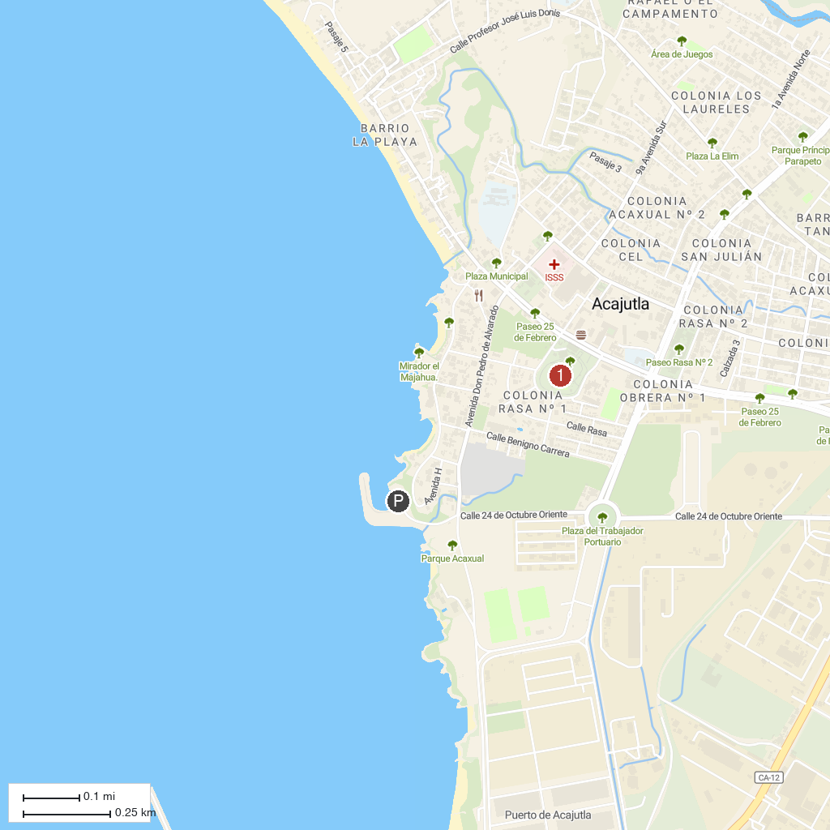
MAP KEY
1. Aquatic Entre Rios Ecopark | 3. Parque Nacional El Imposible
2. Cascadas de Don Juan | 4. Fuente De Flores Parque Botánico
P. Cruise port / terminal
Map © MapTiler © OpenStreetMap contributors · cruiseports.org

