Abu Dhabi, Abu Dhabi, UAE
Where soaring white minarets meet a futuristic skyline — Abu Dhabi packs desert grandeur, world-class museums, and an 8 km waterfront promenade into one opulent shore day.
⚓ Docked (Zayed Port pier) · 🕒 Typical call: 8-10 hrs · 💵 UAE Dirham (AED); cards widely accepted · 🗣️ Arabic (English universally spoken)
✍️ MY DAY IN PORT (FILL IN)
Ship / Date
In port | arrive ______ · all aboard ______
Booked excursion
Notes / meeting point
GETTING ASHORE
- Docking: Docked at Zayed Port Cruise Terminal — no tender required
- Walk to center: ~5 km to Corniche; taxi/shuttle recommended
- Best For: Architecture, culture, desert adventure, theme parks
- Don't Miss: Sheikh Zayed Grand Mosque (free entry, book ahead)
GETTING AROUND
- 🚕 Taxi: AED 27-40 (~$7-11) — Metered taxis queue outside the terminal. The ride to the Corniche or city center takes 7-10 minutes at regulated rates
- 📱 Rideshare: ✅ Uber, Careem
- 🚌 Hop-on hop-off: ✅
TOP THINGS TO DO
- Sheikh Zayed Grand Mosque — The UAE's largest mosque holds 40,000 worshippers and features 82 domes, 1,000 columns, and the world's largest hand-knotted…
- Louvre Abu Dhabi — Jean Nouvel's iconic 'rain of light' dome shelters a permanent collection spanning 5,000 years of global art and civilisation on…
- Qasr Al Watan Presidential Palace — One of the few royal palaces in the Gulf open to the public — ornate Arabian architecture, a vast library, and a dazzling…
- Desert Safari & Dune Bashing — Drive into the Liwa or Al Khatim desert for dune bashing in 4WDs, sandboarding, and a traditional Bedouin camp dinner with camel…
- Mangrove Kayaking — Paddle through Abu Dhabi's Eastern Mangroves National Park, a protected reserve sheltering herons, flamingos, and sea turtles…
BEST WALKS
- Corniche Waterfront Promenade: 3-4 km one way | Flat | 1-1.5 hrs — Abu Dhabi's 8-kilometre Corniche runs along the Arabian Gulf with manicured parks, public beaches…
- Downtown & Emirates Palace Stroll: 2 km loop | Flat | 1 hr — Walk from the Corniche past the landmark Emirates Palace hotel to the nearby Qasr Al Watan palace…
WEATHER · DAYLIGHT · MONEY
Month | High °F | Low °F | Rainy days
May | 98 | 80 | 0
Jul | 105 | 89 | 0
Sep | 102 | 85 | 0
Daylight: May 5:39AM–6:58PM · Jul 5:43AM–7:13PM · Sep 6:08AM–6:26PM
cruiseports.org/abu-dhabi · Confirm terminal & all-aboard time with your ship

Abu Dhabi, Abu Dhabi, UAE — Port Map
Red = walkable sights · Amber = excursions farther out · P = cruise terminal
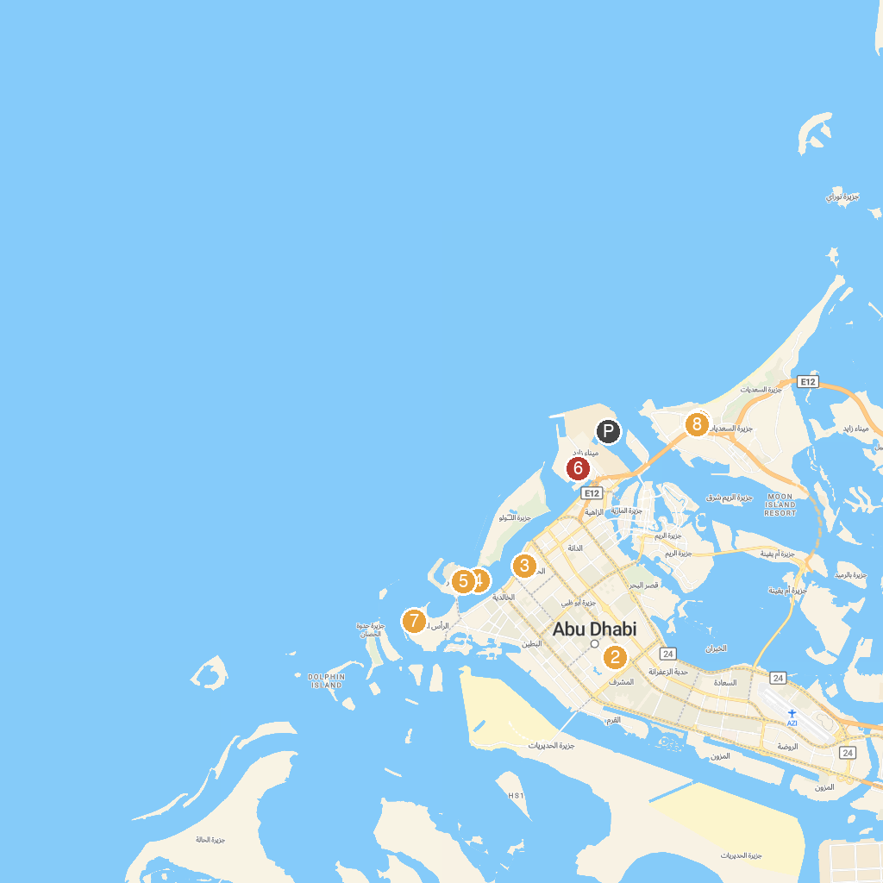
MAP KEY
1. Manarat Al Saadiyat | 5. The Yellow Boats Abu Dhabi
2. St. Joseph's Cathedral | 6. 421 Arts Campus
3. Abu Dhabi Desert Safari | 7. UAE Presidential Palace
4. Emirates Heritage Village | 8. UAE Pavilion
P. Cruise port / terminal
Map © MapTiler © OpenStreetMap contributors · cruiseports.org

