Abidjan, Côte d'Ivoire
West Africa's most dynamic metropolis, spread across lagoons and rising towers — Abidjan punches well above its weight for a cruise call, with a UNESCO colonial town and urban rainforest within easy reach.
⚓ Docked (Vridi Canal quays) · 🕒 Typical call: 8-10 hrs · 💵 West African CFA Franc (XOF) · 🗣️ French (official)
✍️ MY DAY IN PORT (FILL IN)
Ship / Date
In port | arrive ______ · all aboard ______
Booked excursion
Notes / meeting point
GETTING ASHORE
- Docking: Ships berth at Port of Abidjan quays in the Vridi Canal, Treichville district. No tendering.
- Distance to Centre: Plateau (city centre) ~6 km by road; taxis and shuttles available at the port gate.
- Best For: Colonial history, West African market culture, urban nature, and cuisine.
- Don't Miss: Grand-Bassam UNESCO historic quarter — 45 min by road, essential for any call here.
GETTING AROUND
- 🚕 Taxi: XOF 3,000–6,600 (~$5–$11) — Taxis are widely available but meters are rarely used — always negotiate the fare before you get in. The port sits in Tr
- 📱 Rideshare: ✅ Yango, Heetch, InDrive
TOP THINGS TO DO
- Grand-Bassam UNESCO Colonial Town — Côte d'Ivoire's first French colonial capital (1893–1896) is a 45-minute drive east.
- Banco National Park — An extraordinary pocket of equatorial primary rainforest entirely within the city limits.
- Treichville Market & City Tour — Plunge into the Grand Marché de Treichville — one of West Africa's great urban markets, piled high with textiles, spices, crafts…
- Ivorian Street Food & Maquis Lunch — Côte d'Ivoire has one of West Africa's most celebrated food cultures.
- Musée des Civilisations de Côte d'Ivoire — The national civilisations museum in the Plateau district houses an impressive collection of Ivorian masks, traditional costumes…
BEST WALKS
- Plateau District Highlights Walk: 2 km · Easy · 45–60 min — Start at the Plateau waterfront on the Ébrié Lagoon, walk past the CEDEAO building and the…
WEATHER · DAYLIGHT · MONEY
Month | High °F | Low °F | Rainy days
May | 85 | 75 | 29
Jul | 81 | 73 | 27
Sep | 81 | 73 | 28
Daylight: May 6:01AM–6:23PM · Jul 6:10AM–6:33PM · Sep 6:06AM–6:15PM
cruiseports.org/abidjan · Confirm terminal & all-aboard time with your ship

Abidjan, Côte d'Ivoire — Port Map
Red = walkable sights · Amber = excursions farther out · P = cruise terminal
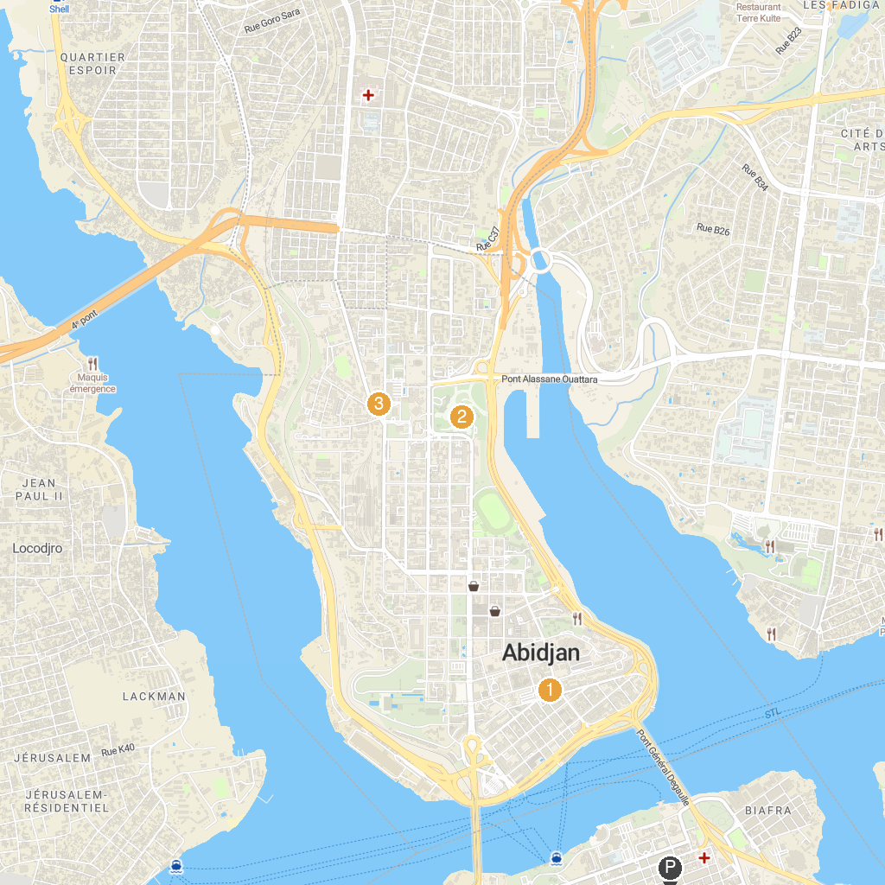
MAP KEY
1. Salam Mosque of Plateau | 3. Musée des Civilisations de Côte d'Ivoire
2. St. Paul's Cathedral
P. Cruise port / terminal
Map © MapTiler © OpenStreetMap contributors · cruiseports.org

