Aberdeen, Scotland, United Kingdom
The Granite City wears its stone proudly — grey skies, cliff-top castles, and a royal Highland hinterland just an hour's drive away. Aberdeen is a port with serious punching power for a one-day stop.
⚓ Docked (North or South Harbour) · 🕒 Typical call: 8-10 hrs · 💷 GBP (pound sterling) · 🗣️ English
✍️ MY DAY IN PORT (FILL IN)
Ship / Date
In port | arrive ______ · all aboard ______
Booked excursion
Notes / meeting point
GETTING ASHORE
- Docking: All berths alongside — no tender. Larger ships use South Harbour (Balmoral Quay), ~3 km from centre; smaller ships dock at North Harbour, ~1.2 km walk.
- Walk to centre: 15-20 min from North Harbour; shuttle or taxi needed from South Harbour.
- Best For: Castle day-trips, Scotch whisky, Royal Deeside scenery, coastal walks
- Don't Miss: Dunnottar Castle — one of Scotland's most dramatic clifftop ruins, 27 km south by car or tour.
GETTING AROUND
- 🚕 Taxi: £8–£12 — Taxis from South Harbour (Balmoral Quay) to the city center take about 10 minutes. The port is ~2 miles from Union Stree
- 📱 Rideshare: ✅ Uber
- 🚌 Hop-on hop-off: ✅ Aberdeen Adventurer
TOP THINGS TO DO
- Dunnottar Castle & Stonehaven — A ruined fortress perched on a sheer 50 m sea cliff south of Aberdeen — one of Scotland's most photographed sites.
- Royal Deeside & Balmoral Castle — Drive west into the Cairngorms National Park to Balmoral, the Royal Family's Scottish summer retreat.
- Aberdeen City Walk: Marischal College & Old Aberdeen — Marischal College is one of the world's largest granite buildings — its elaborately carved façade is unmissable.
- Scotch Whisky Distillery Visit — Aberdeenshire sits on the edge of Speyside malt country.
- Dolphin & Wildlife Spotting — Aberdeen Harbour is one of the best land-based bottlenose dolphin viewing spots in Scotland, particularly April–July.
BEST WALKS
- Union Street to Old Aberdeen: 3 km · 45-60 min one way · Easy — Walk the length of Union Street, Aberdeen's grand granite main street, then continue north through…
- Footdee (Fittie) & Beach Promenade: 2 km · 30 min · Easy — From the North Harbour, walk east to Footdee — a charming 19th-century fishermen's village of…
WEATHER · DAYLIGHT · MONEY
Month | High °F | Low °F | Rainy days
May | 54 | 45 | 13
Jul | 62 | 53 | 16
Sep | 59 | 51 | 13
Daylight: May 4:49AM–9:21PM · Jul 4:36AM–9:51PM · Sep 6:39AM–7:26PM
cruiseports.org/aberdeen · Confirm terminal & all-aboard time with your ship

Aberdeen, Scotland, United Kingdom — Port Map
Red = walkable sights · Amber = excursions farther out · P = cruise terminal
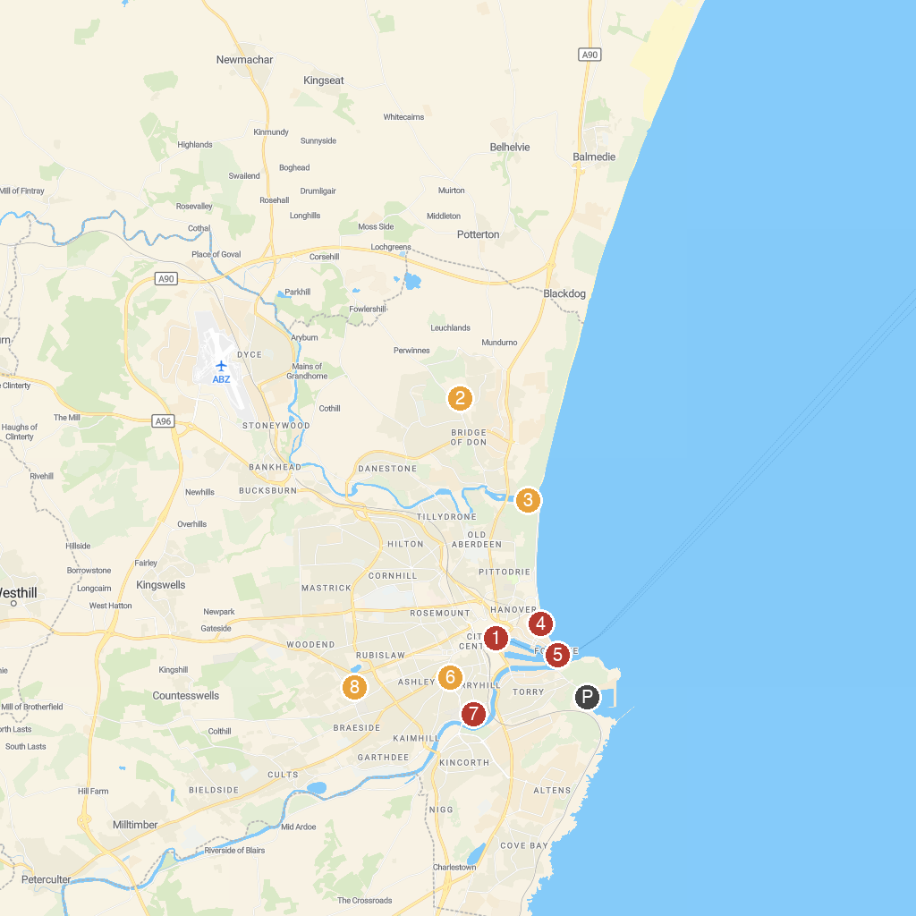
MAP KEY
1. Aberdeen Maritime Museum | 5. Footdee
2. Scotstown Moor Local Nature Reserve | 6. The Locked Door Escape Games
3. Donmouth Local Nature Reserve | 7. Duthie Park
4. Queens Links Leisure Park | 8. Johnston Gardens
P. Cruise port / terminal
Map © MapTiler © OpenStreetMap contributors · cruiseports.org

