Abashiri, Hokkaido, Japan
A raw corner of northeastern Hokkaido where drift ice meets dense forest and Japan's most storied prison sits beside a UNESCO wilderness. Abashiri rewards the curious with landscapes and history you won't find anywhere else in the country.
⚓ Docked — No. 4 Wharf · 🕒 Typical call: 8-10 hrs · 💴 Currency: Japanese Yen (JPY) · 🗣️ Language: Japanese · ❄️ Famous for Okhotsk drift ice
✍️ MY DAY IN PORT (FILL IN)
Ship / Date
In port | arrive ______ · all aboard ______
Booked excursion
Notes / meeting point
GETTING ASHORE
- Docking: Ships berth at No. 4 Wharf (Pier 2) in Abashiri Port — no tendering required
- Walk to center: ~10-15 min walk or short taxi/bus to central Abashiri town
- Best For: History buffs, nature lovers, seafood, and winter drift-ice experiences
- Don't Miss: Okhotsk Ryuhyo (Drift Ice) Museum and Abashiri Prison Museum
GETTING AROUND
- 🚕 Taxi: ¥900–1,500 (~$6–10 USD) — Taxis are available at the port and the city is compact. Quick 5–10 min ride to Abashiri Station or main sights; no adva
TOP THINGS TO DO
- Abashiri Prison Museum — Walk through the original Meiji-era buildings of Japan's most notorious prison, relocated and preserved as an open-air museum.
- Okhotsk Ryuhyo (Drift Ice) Museum — Perched atop Mount Tento, this museum lets you touch real drift ice in a -15°C chamber year-round, while panoramic windows frame…
- Shiretoko National Park Day Trip — A UNESCO World Natural Heritage site 60–90 min from port, Shiretoko is Hokkaido's wildest corner.
- Hokkaido Museum of Northern Peoples — A small but excellent museum dedicated to the Indigenous Ainu people of Hokkaido and other northern circumpolar peoples, with…
- Lake Abashiri & Lake Notoro Scenic Drive — Abashiri's two iconic lakes offer striking seasonal beauty — crimson coral grass at Notoro in autumn, white-tailed eagles and…
BEST WALKS
- Port to Abashiri Town Center: 1 km · ~15 min · flat — An easy flat walk from the port gate through the harbor district into Abashiri's compact downtown.
- Mount Tento Summit Walk: ~30 min ascent · moderate — A forested trail winds up Mount Tento to the Okhotsk Drift Ice Museum and observation deck at the…
WEATHER · DAYLIGHT · MONEY
Month | High °F | Low °F | Rainy days
May | 60 | 45 | 11
Jul | 73 | 61 | 10
Sep | 69 | 57 | 12
Daylight: May 3:57AM–6:41PM · Jul 3:54AM–7:03PM · Sep 5:02AM–5:33PM
cruiseports.org/abashiri · Confirm terminal & all-aboard time with your ship

Abashiri, Hokkaido, Japan — Port Map
Red = walkable sights · Amber = excursions farther out · P = cruise terminal
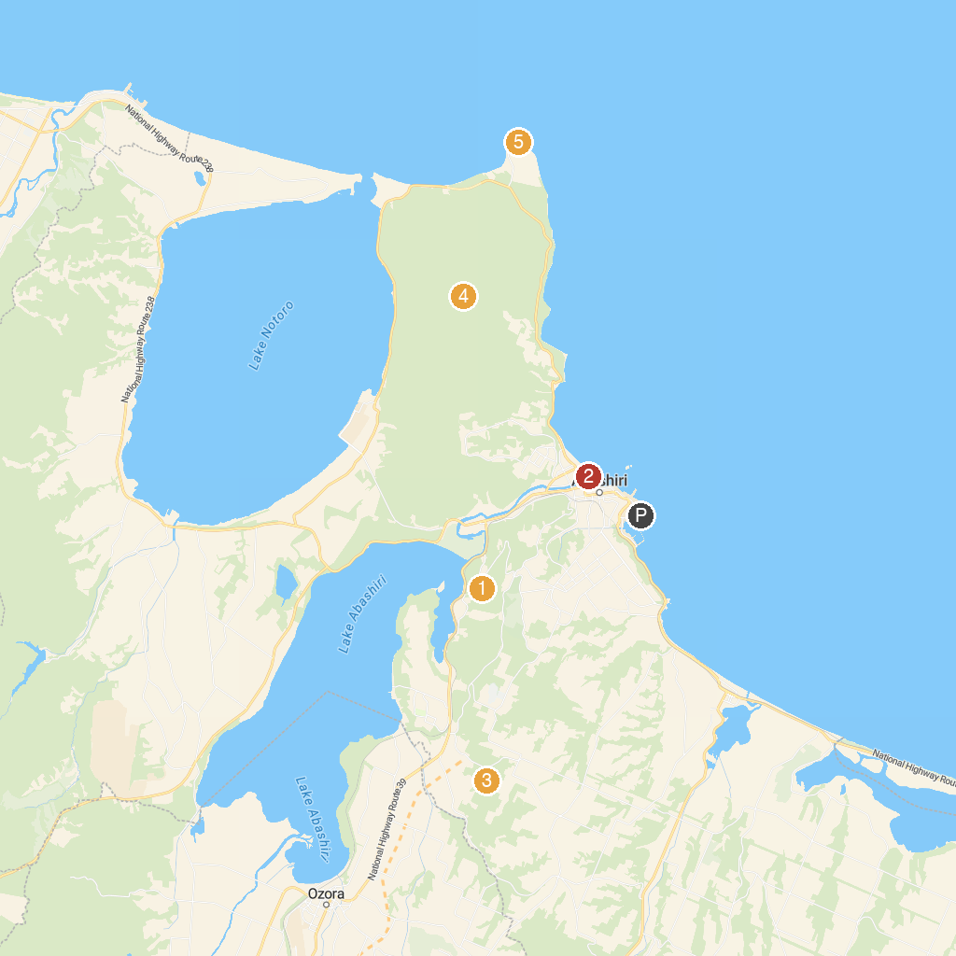
MAP KEY
1. Abashiri Prison Museum | 5. Abashiri Quasi-National Park (Sea of Okhotsk coast and seven lagoon lakes centered on Abashiri)
2. Koshimizu genseikaen primeval flower garden | 6. Cape Notoro-misaki
3. Moyoro Shell Mound Museum | 7. View Point Parking Memanbetsu "Meruhen no Oka"
4. Abashiri Phlox Park | 8. Ubaranai Glasswort community
P. Cruise port / terminal
Map © MapTiler © OpenStreetMap contributors · cruiseports.org

