Aarhus, Denmark
Denmark's vibrant second city — a young, design-forward hub where a rainbow-ringed art museum, a living history town, and cobbled Latin Quarter lanes are all an easy walk from your ship.
⚓ Docked (city center) · 🕒 Typical call: 8–10 hrs · 💵 Danish Krone (DKK) · 🗣️ Danish · English universal
✍️ MY DAY IN PORT (FILL IN)
Ship / Date
In port | arrive ______ · all aboard ______
Booked excursion
Notes / meeting point
GETTING ASHORE
- Docking: Aarhus cruise quay
- Walk to center: 10–15 min
- Best For: Art · Design · History
- Don't Miss: ARoS rainbow
GETTING AROUND
- 🚕 Taxi: ~DKK 100 (≈ USD) — Taxis queue at the terminal. Fares are regulated; the port-to-center ride is roughly DKK 100. A 1-hour narrated taxi cit
- 📱 Rideshare: ✅ Uber, Bolt
- 🚌 Hop-on hop-off: ✅ City Sightseeing / Stromma
TOP THINGS TO DO
- ARoS Art Museum & Rainbow Panorama — Walk the circular rooftop 'Your Rainbow Panorama' by Olafur Eliasson — a 360° ring of colored glass over the city — atop one of…
- Den Gamle By Open-Air Museum — A 'living' town of 75 historic Danish buildings re-erected with costumed townsfolk — a charming walk through centuries of…
- Aarhus Latin Quarter & Cathedral — The medieval lanes of cafés, boutiques, and the towering Aarhus Cathedral — Denmark's longest church — at the heart of the old…
- Moesgaard Museum & Coast — The striking grass-roofed Moesgaard museum of prehistory (home to the Grauballe bog man), with forest and beach trails down to…
BEST WALKS
- Cathedral & Latin Quarter: ~2 km · 1.5 hrs · easy — From the harbour to the soaring Aarhus Cathedral, then into the cobbled Latin Quarter's lanes of…
- ARoS & city hall: ~2 km · 1 hr · easy — Up to the ARoS museum with its rainbow ring, past Arne Jacobsen's modernist City Hall with its…
- Aarhus Å riverside & harbour: ~2 km · 1 hr · easy — The reopened river running through the center, lined with bars and cafés, leading down to the…
WEATHER · DAYLIGHT · MONEY
Month | High °F | Low °F | Rainy days
May | 59 | 46 | 13
Jul | 69 | 56 | 13
Sep | 63 | 53 | 11
Daylight: May 5:05AM–9:26PM · Jul 4:53AM–9:55PM · Sep 6:51AM–7:36PM
cruiseports.org/aarhus · Confirm terminal & all-aboard time with your ship

Aarhus, Denmark — Port Map
Red = walkable sights · Amber = excursions farther out · P = cruise terminal
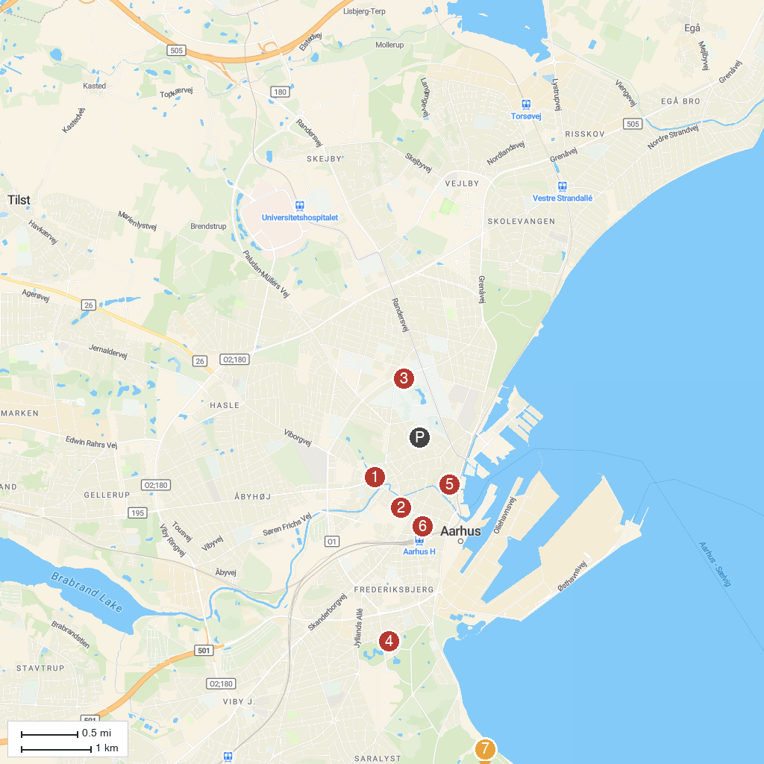
MAP KEY
1. The Old Town | 5. Aarhus Cathedral
2. ARoS Aarhus Art Museum | 6. Catholic Church of Our Lady
3. Museum of Ancient Art, Aarhus | 7. Marselisborg Deer Park
4. Tivoli Friheden
P. Cruise port / terminal
Map © MapTiler © OpenStreetMap contributors · cruiseports.org

