Aalborg, Jutland, Denmark
Denmark's fourth-largest city punches above its weight — a medieval old town, a landmark Viking burial site, and a revitalized waterfront, all reachable on foot from the cruise berth.
⚓ Docked (Honnørkajen pier) · 🕒 Typical call: 8–10 hrs · 💵 Danish Krone (DKK); cards accepted everywhere · 🗣️ Danish (English widely spoken)
✍️ MY DAY IN PORT (FILL IN)
Ship / Date
In port | arrive ______ · all aboard ______
Booked excursion
Notes / meeting point
GETTING ASHORE
- Docking: Honnørkajen (Royal Cruise Berth), 200 m from city center
- Walk to center: 2–5 min flat walk to main square and shops
- Best For: History, Viking culture, street art, Nordic food & aquavit
- Don't Miss: Lindholm Høje Viking burial site; Jens Bang's House
GETTING AROUND
- 🚕 Taxi: DKK 65–160 (~$9–23) — Base fare DKK 45 plus DKK 12.10/km. Short rides from secondary quays to city center run DKK 65–75; longer sightseeing tr
- 📱 Rideshare: ✅ Uber
TOP THINGS TO DO
- Lindholm Høje Viking Burial Ground — Scandinavia's best-preserved Viking burial site, just north of the city.
- Old Town Walking Tour — Stroll from Aalborghus Castle along the waterfront to Jens Bang's House (1624 Dutch Renaissance mansion), Budolfi Cathedral, and…
- Street Art & Waterfront Design Walk — Aalborg is one of Scandinavia's street art capitals.
- Kunsten Museum of Modern Art — A striking building designed by Alvar Aalto houses one of Denmark's finest collections of 20th-century and contemporary art, with…
- Aquavit & Nordic Food Experience — Aalborg gave its name to Denmark's most famous aquavit — Aalborg Akvavit was first distilled here in 1846 and the city was long…
BEST WALKS
- Historic Core Walk: 2.5 km · 45–60 min · Easy — From the cruise berth, cross to Aalborghus Castle, then head inland past the Utzon Center to the…
- Waterfront & Street Art Loop: 3 km · 1 hr · Easy — Head east along the revitalized harbor, spotting murals on the warehouse walls.
WEATHER · DAYLIGHT · MONEY
Month | High °F | Low °F | Rainy days
May | 60 | 46 | 12
Jul | 69 | 56 | 15
Sep | 63 | 53 | 12
Daylight: May 5:01AM–9:32PM · Jul 4:48AM–10:02PM · Sep 6:51AM–7:38PM
cruiseports.org/aalborg · Confirm terminal & all-aboard time with your ship

Aalborg, Jutland, Denmark — Port Map
Red = walkable sights · Amber = excursions farther out · P = cruise terminal
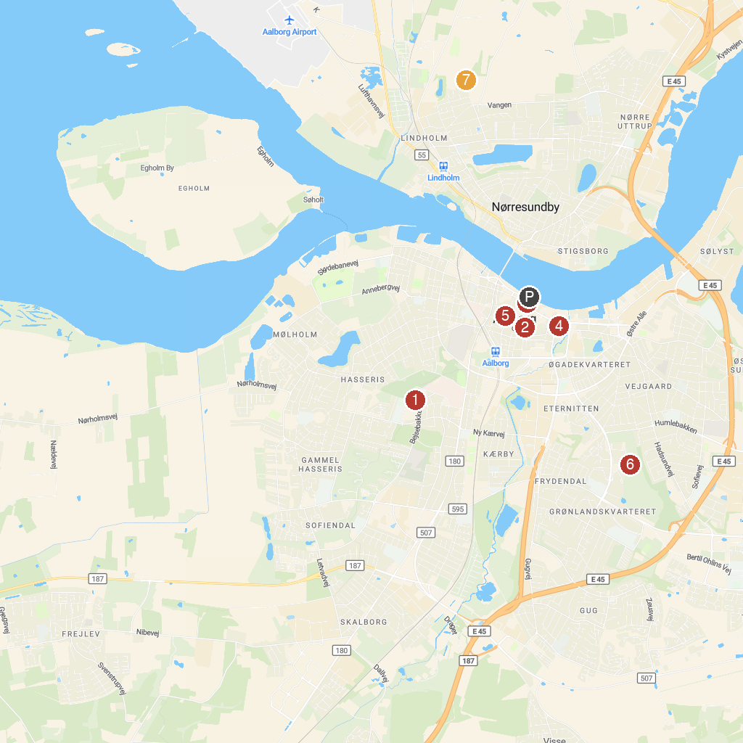
MAP KEY
1. Aalborg Zoo | 5. Budolfi Church
2. Church of Our Lady | 6. Urania Observatory
3. Aalborghus Castle | 7. Vikingemuseet Lindholm Høje
4. Nordkraft
P. Cruise port / terminal
Map © MapTiler © OpenStreetMap contributors · cruiseports.org

